

ONLINE SUPPLEMENTARY DOCUMENT

Lopes Simões M, Oliveira Veras M, Fracolli L A, Miani, C. The Integration of Social Determinants of Health in Antenatal Care Policies in Brazil: A Content Analysis of Five Federal Documents. Journal of Global Health Economics and Policy.2026;6:e2026034.

Figures and Tables - The Integration of Social Determinants of Health in Antenatal Care Policies in Brazil: A Content Analysis of Five Federal Documents

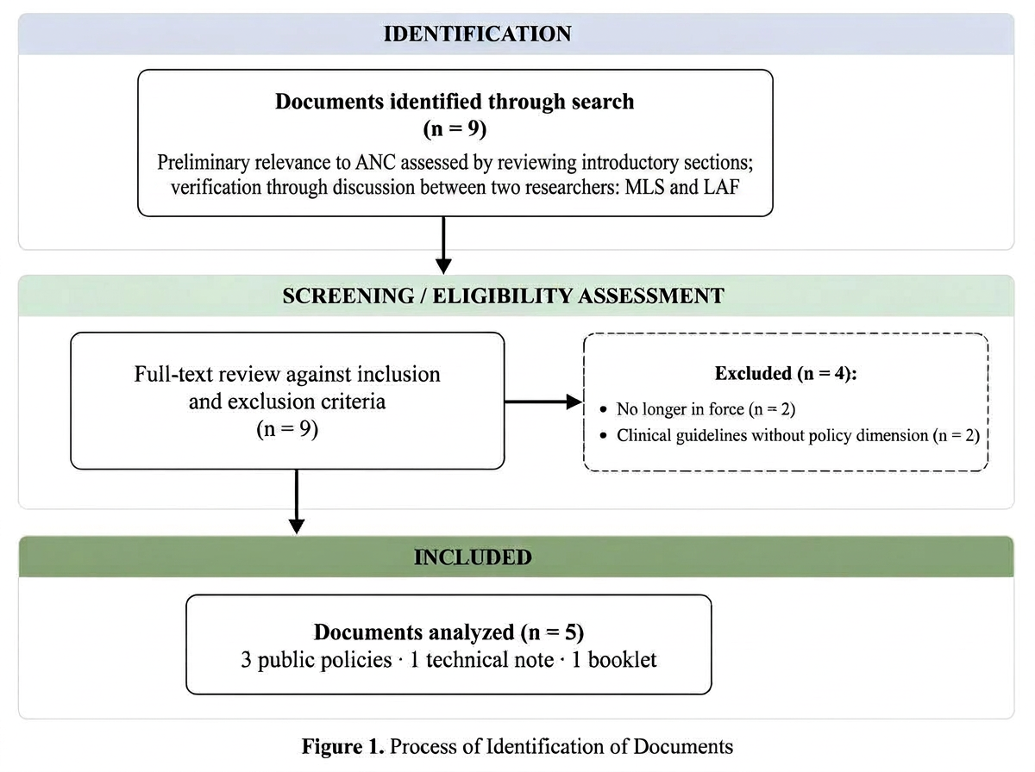
Figure 1 - Document Identification Process

Table 3- General Goals of the Policies Analyzed
 | PNAISM | Humanization Program for Prenatal and Birth Care | Pregnant Woman’s Health Booklet | Alyne Network | Joint Technical Note | Totals
Across the gradient | 3 | 0 | 0 | 5 | 4 | 12
Average health | 4 | 1 | 1 | 3 | 5 | 14
Close the gap | 0 | 0 | 0 | 0 | 1 | 1
Equity groups | 10 | 0 | 0 | 5 | 2 | 17
Subject to ill health | 2 | 0 | 0 | 0 | 0 | 2
Totals | 19 | 1 | 1 | 13 | 12 | 46

Table 4- Frequency of Coded Excerpts for General System-Level Objectives and Strategies related to SDH Across Documents
 | PNAISM | Humanization Program for Prenatal and Birth Care | Pregnant Woman’s Health Booklet | Alyne Network | Joint Technical Note | Totals
System-level Objectives
Reducing Social Inequalities | 9 | 0 | 0 | 8 | 2 | 19
Health service access | 4 | 4 | 0 | 3 | 0 | 11
Health promotion and disease prevention | 4 | 2 | 0 | 0 | 0 | 6
Collaboration between health services | 2 | 0 | 0 | 1 | 1 | 4
Health service quality | 0 | 4 | 0 | 0 | 0 | 4
Community engagement | 1 | 0 | 0 | 1 | 1 | 3
Cross-sector activity | 1 | 0 | 0 | 0 | 0 | 1
Workforce | 0 | 0 | 0 | 1 | 0 | 1
TOTAL |  |  |  |  |  | 49
System-Level Strategies
Health service quality | 11 | 12 | 3 | 15 | 7 | 48
Health service access | 4 | 6 | 1 | 23 | 5 | 39
Health promotion and disease prevention | 6 | 2 | 7 | 8 | 9 | 32
Reducing Social Inequalities | 9 | 3 | 1 | 7 | 2 | 22
Collaboration between health services | 2 | 1 | 0 | 7 | 6 | 16
Community engagement | 7 | 0 | 0 | 4 | 1 | 12
Workforce | 4 | 0 | 0 | 0 | 0 | 4
Cross-sector activity | 2 | 0 | 0 | 1 | 0 | 3
TOTAL |  |  |  |  |  | 176
Totals | 66 | 34 | 12 | 79 | 34 | 225

Table 5 - Frequency of Coded Excerpts for System-Level Strategies related to SDH affecting ANCU Across Documents
System-Level Strategies related to ANCU | PNAISM | Humanization Program for Prenatal and Birth Care | Pregnant Woman’s Health Booklet | Alyne Network | Joint Technical Note | Totals
Violence against women | 7 | 5 | 8 | 17 | 2 | 39
Media / Information | 5 | 6 | 15 | 3 | 0 | 29
Race / Ethnicity | 12 | 0 | 1 | 6 | 3 | 22
Cultural / Social norms | 4 | 0 | 2 | 5 | 1 | 12
Spousal / Family influence | 4 | 2 | 3 | 3 | 0 | 12
Age | 2 | 0 | 1 | 4 | 0 | 7
Urban vs. rural residence | 4 | 0 | 0 | 2 | 0 | 6
Wealth / Income | 2 | 0 | 0 | 2 | 1 | 5
Educational level | 1 | 0 | 0 | 2 | 0 | 3
Employment / Occupation | 1 | 0 | 0 | 2 | 0 | 3
TOTAL |  |  |  |  |  | 138

