Supplementary Information

Supplementary figure 1
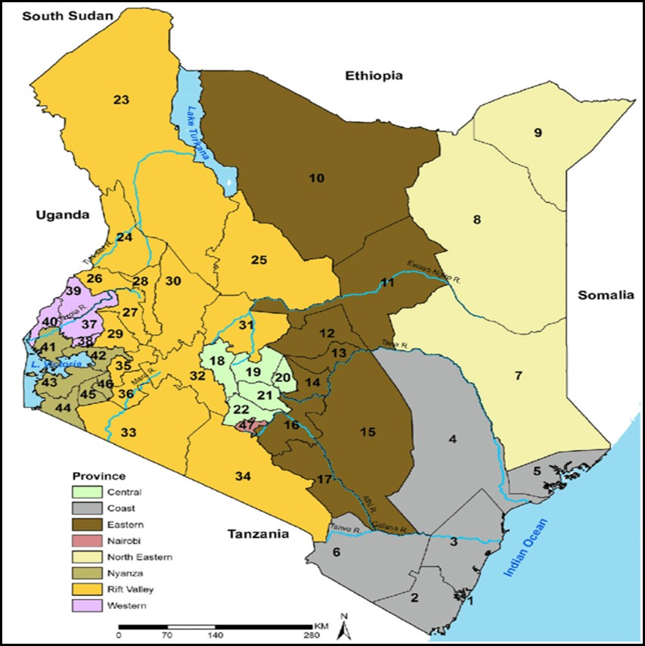
Supplementary Figure 1: Map of Kenya. Source KNBS, 2023 [23].
Coast province: Mombasa (1), Kwale (2), Kilifi (3), Tana River (4), Lamu (5), Taita Taveta (6); North Eastern province: Garissa (7), Wajir (8), Mandera (9); Eastern province: Marsabit (10), Isiolo (11), Meru (12), Tharaka Nithi (13), Embu (14), Kitui (15), Machakos (16), Makueni (17); Central province: Nyandarua (18), Nyeri (19), Kirinyaga (20), Murang'a (21), Kiambu (22); Rift Valley province: Turkana (23), West Pokot (24), Samburu (25), Trans Nzoia (26), Uasin Gishu (27), Elgeyo Marakwet (28), Nandi (29), Baringo (30), Laikipia (31), Nakuru (32), Narok (33), Kajiado (34), Kericho (35), Bomet (36); Western province: Kakamega (37), Vihiga (38), Bungoma (39), Busia (40); Nyanza province: Siaya (41), Kisumu (42), Homa Bay (43), Migori (44), Kisii (45), Nyamira (46); Nairobi province: Nairobi (47)

Supplementatary figure 2
Supplementary Figure 2: Subplots depicting DTP1 and DTP3 vaccination trends in high performing counties according to the national mean average coverage.
Supplementatary figure 3

Supplementary Figure 3: Subplots depicting DTP1 and DTP3 vaccination trends in low performing counties according to the national mean average coverage.

Supplementatary figure 4

Supplementary figure 4: Monthly DTP1 and DTP3 vaccination volumes in Kenya, 2020-2024, with COVID-19 disruption (April 2020-March 2021) shown in the left panel and excluded in the sensitivity analysis (right). The dashed line indicates the pre-COVID-19 DTP baseline.

Supplementatary figure 5

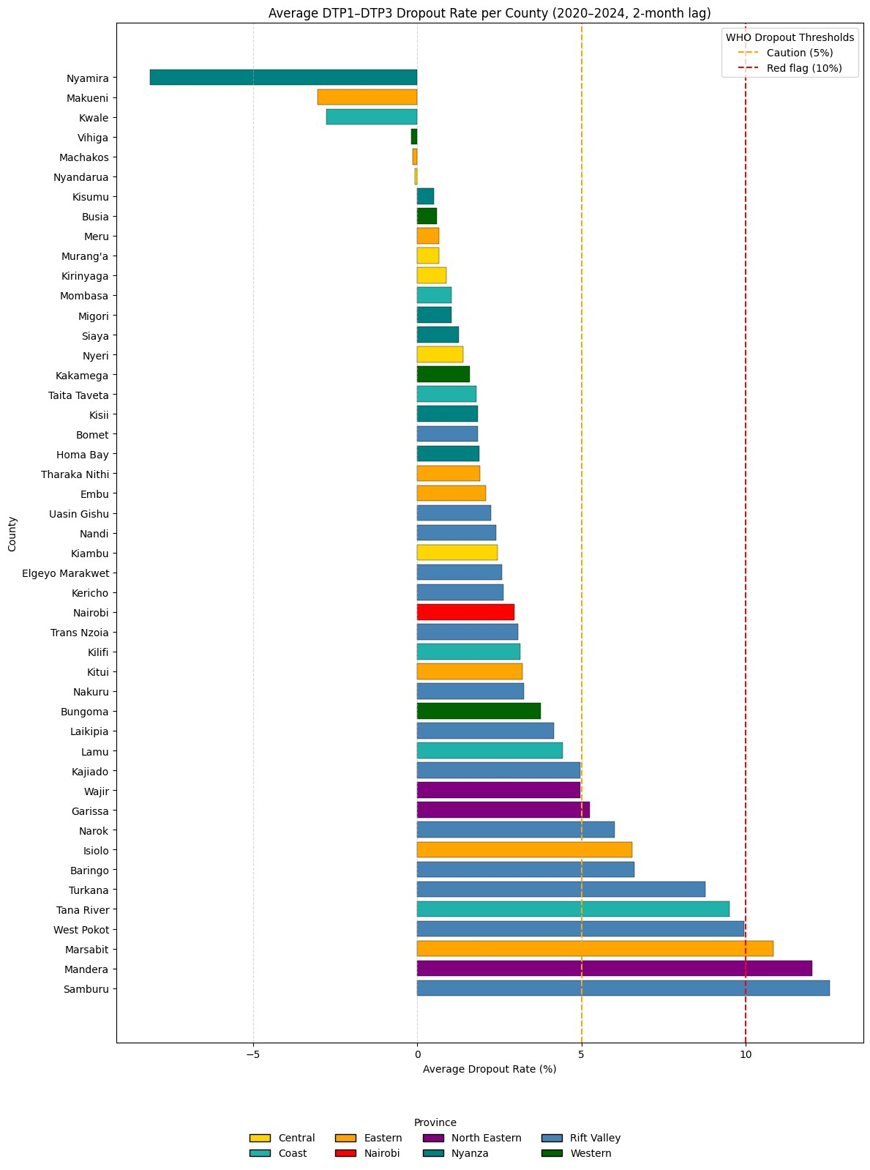
Supplementary figure 5: County average dropout rates from 2020 to 2024, colour-coded according to geographical region. Most counties are below the 5% caution threshold.

Supplementary figure 6

Supplementary figure 6: (A)The relationship between the DTP1–DTP3 dropout rate and health facility density per 10,000 population. Circles represent counties, colour-coded by geographical region. The black line shows the regression fit with a 95% confidence band (grey), and the red dashed vertical line denotes the national mean facility density. There is a very weak negative correlation between dropout rate and health facility density. (B) Residuals vs fitted values from the linear regression model showing no systematic pattern and supporting the adequacy of the linear model

Supplementary Text 1
Visualisation of Health facility distribution and DTP1-DTP3 dropout rates
Supplementary figure 6 presented a comparison between county level DTP-DTP3 dropout rates (left map) and health facility density per 10,000 population (right map).
On the left map, dropout rates from 2020-2024 varied widely by county. In the north and northeastern areas (e.g.Turkana, Samburu, Mandera, Marsabit and Wajir) exhibited the highest dropout rates, surpassing 5% and reaching up to 12.5%. In contrast, counties in parts of central and southeastern Kenya (e. g. Kirinyaga, Nyeri, Machakos and Makueni) showed very low dropout rates, many below 2%. Six counties, represented in grey, reported negative dropout.

The right map showed facility density per 10,000 population. Counties in central and parts of the southern region in Kenya had higher facility densities, often exceeding 3.5 per 10,000 population. Conversely, counties in the arid and semi-arid counties in the northeastern areas had the lowest facility densities, frequently below 2.5 per 10000 population.

Supplementatary figure 7

Supplementary figure 7: Maps of Kenya comparing the average county DTP1 to DTP3 dropout rates (left) and health facility distribution per 10000 population (right) from 2020 to 2024. A graduated red to yellow colour scheme representing decreasing dropout and health facility densities.

