
Online Supplementary Document
Table of Contents
Figure S1. Decision tree for vaccine hesitancy classification 2
Figure S2. Scree plot of exploratory factor analysis for psychological constructs 3
Table S1-1. The result of vaccine attitudes and the factor loadings of 4 psychological constructs 4
Table S1-2. The factor correlation matrix of 4 psychological constructs 5
Table S2. The association between VS, characteristics, and 5 psychological constructs 6
Table S3. The factor correlation matrix of 5 psychological constructs 8
Table S4-1. The association between VS, fear, and the 4 psychological constructs 9
Table S4-2. The association between VS, fear, and 5 psychological constructs 10
Table S5. The association between VS and information sources 11
Table S6. STROBE statement 12
Reference 13

Note: The original questionnaire and data can be accessed through
https://ars.els-cdn.com/content/image/1-s2.0-S0033350624004888-mmc1.docx
Parisi, A., Regazzi, L., Spanaus, E. S., Valz Gris, A., Cadeddu, C., Moore, M., Ricciardi, W., & Lomazzi, M. (2025). Impact of COVID-19 pandemic on vaccine hesitancy and sentiment changes: A survey of healthcare workers in 12 countries. Public Health, 238, 188-196. https://doi.org/https://doi.org/10.1016/j.puhe.2024.11.016

Figure S1. Decision tree for vaccine hesitancy classification
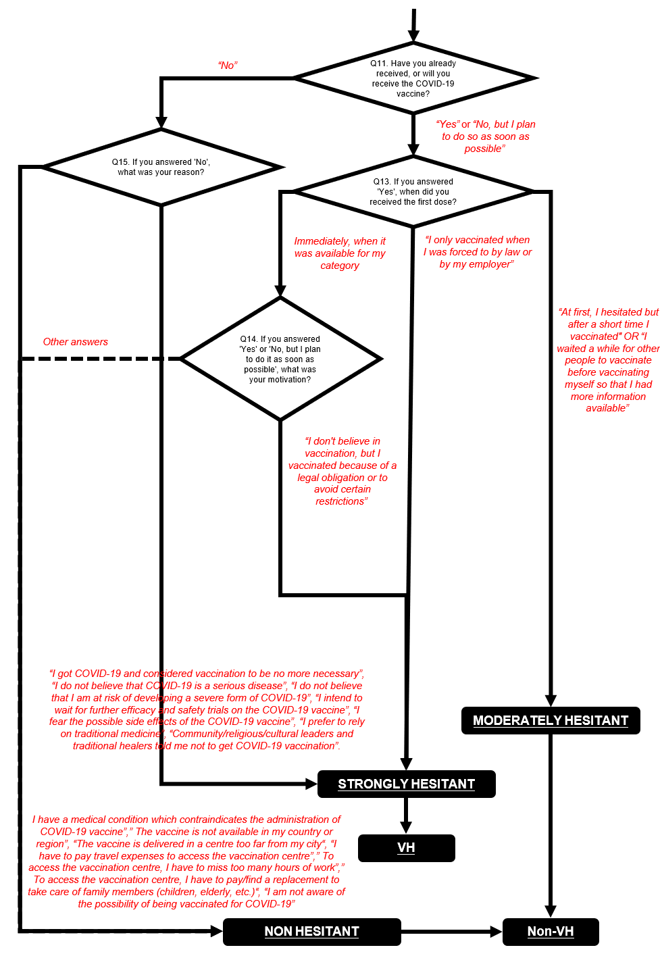
Note: Based on the definition ¹ and prior results ², questions about vaccine history (Q11, 13), vaccine uptake reasons (Q14), and vaccine intentions (Q15) were used to determine vaccine-hesitant or vaccine-non-hesitant.

Figure S2. Scree plot of exploratory factor analysis for psychological constructs

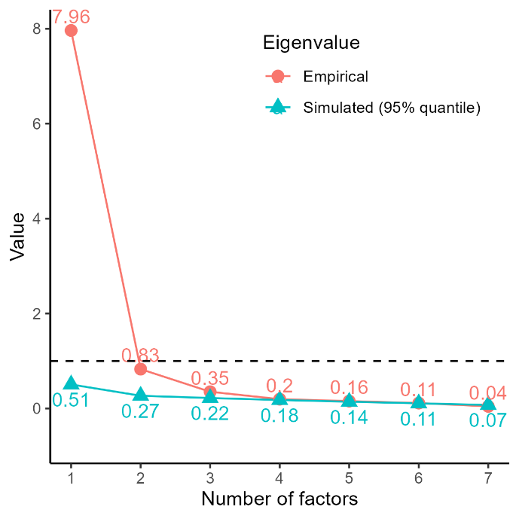
Note: The "Empirical" line (solid circles) represents the eigenvalues derived from the actual sample data, while the "Simulated (95% quantile)" line (solid triangles) represents the 95th percentile of eigenvalues from simulated random data of the same dimensions. The horizontal dashed black line indicates an eigenvalue of 1, corresponding to the traditional Kaiser criterion.

Table S1-1. The result of vaccine attitudes and the factor loadings of 4 psychological constructs
Questions for vaccine attitudes | Agree |  | Factor loadings of psychological constructs
Questions for vaccine attitudes | N | % | Collective responsibility | Confidence | Complacency | Constraints
General vaccine attitudes (n=580)
Q9-1 Vaccines are scientifically tested and are among the safest pharmaceutical products | 549 | 94.7 | - | 0.922 | - | -
Q9-2 Vaccines are an indispensable tool to protect individuals and communities | 568 | 97.9 | - | 0.684 | - | -
Q9-3 Side effects of vaccines are minimized by pharmaceutical companies | 290 | 50.0 | - | - | 1.011 | -
Q9-4 Side effects of vaccines are minimized by public health authorities | 240 | 41.4 | - | - | 0.769 | -
Q9-5 Regarding vaccines, I am confident that public authorities will decide in the best interest of the community | 469 | 80.9 | - | 0.296 | - | -
Q9-6 Vaccines have a significant impact on stopping the spread of infectious diseases | 501 | 86.4 | - | 0.331 | - | -
COVID-19 vaccine attitudes (n=544)
Q10-1 The risk of complications due to COVID-19 disease is greater than the risk of serious adverse effects from the COVID-19 vaccine | 510 | 93.8 | 0.486 | - | - | -
Q10-2 It is preferable to acquire immunity against COVID-19 by contracting the infection rather than through vaccination | 88 | 16.2 | -0.387 | - | - | -
Q10-3 There is insufficient evidence on the efficacy and safety of COVID-19 vaccines due to their rapid development | 87 | 16.0 | -0.568 | - | - | -
Q10-4 The COVID-19 vaccine is effective in reducing the risk of developing severe forms of COVID-19 disease | 515 | 94.7 | 0.404 | - | - | 0.415
Q10-5 Only adults should be vaccinated against COVID-19 | 50 | 9.2 | -0.827 | - | - | -
Q10-6 Pregnant women should be vaccinated against COVID-19 | 472 | 86.8 | 0.814 | - | - | -
Q10-7 Children and adolescents should be vaccinated against COVID-19 | 503 | 92.5 | 0.891 | - | - | -
Q10-8 I agree with the mandatory COVID-19 vaccine for health professionals (with no medical impediments) | 470 | 86.4 | 0.642 | - | - | -
Q10-9 Work restrictions should be envisaged for health professionals who refuse to be vaccinated against COVID-19 despite having no medical impediments | 395 | 72.6 | 0.636 | - | - | -
Q10-10 It is important that community/religious/cultural leaders and traditional healers reinforce the positive message about COVID-19 vaccination | 497 | 91.4 | 0.568 | - | - | 0.339
Q10-11 Easy access to the vaccination is a key lever for increasing COVID-19 vaccination | 525 | 96.5 | - | - | - | 0.657
Sum of squared loadings |  |  | 4.96 | 2.23 | 1.71 | 1.46
Proportion of variance |  |  | 0.29 | 0.13 | 0.10 | 0.09
Cumulative proportion of variance |  |  | 0.29 | 0.42 | 0.52 | 0.61
Internal reliability (Cronbach’s alpha) |  |  | 0.91 | 0.68 | 0.88 | 0.85
Note: Agree includes answers “strongly agree and agree”; Disagree includes answers “strongly disagree and disagree.” GCR, General collective responsibility; OCR, Obligated collective responsibility. Factor loadings greater than 0.26 were deemed significant and are shown in the table.

Table S1-2. The factor correlation matrix of 4 psychological constructs

Psychological constructs | Collective responsibility | Confidence | Constraints | Complacency
Collective responsibility | 1.00 | 0.75 | -0.29 | 0.63
Confidence |  | 1.00 | -0.21 | 0.58
Constraints |  |  | 1.00 | -0.08
Complacency |  |  |  | 1.00

Table S2. The association between VS, characteristics, and 5 psychological constructs
Explanatory variables | VS1:  Vaccine attention | VS2:  Vaccine intention | VS3:  Vaccine confidence | VS4:  General attitude | VS5:  Health system confidence
Agree¹ n (%) | 429 (84.4%) | 419 (82.5%) | 388 (76.4%) | 375 (73.8%) | 364 (71.7%)
Gender (ref: female)
male | 0.84² | 1.11 | 1.07 | 1.13 | 1.14
male | [0.47, 1.50] | [0.47, 2.66] | [0.60, 1.91] | [0.68, 1.88] | [0.69, 1.88]
male | p=0.553 | p=0.808 | p=0.819 | p=0.625 | p=0.611
Age (ref: 18-25)
35-44 | 0.87 | 1.03 | 1.03 | 2.02* | 0.92
35-44 | [0.39, 1.95] | [0.37, 2.89] | [0.49, 2.14] | [1.10, 3.71] | [0.49, 1.72]
35-44 | p=0.738 | p=0.955 | p=0.947 | p=0.023 | p=0.796
45-54 | 1.28 | 2.30 | 1.21 | 2.08* | 1.97
45-54 | [0.51, 3.24] | [0.71, 7.48] | [0.53, 2.77] | [1.03, 4.19] | [0.92, 4.24]
45-54 | p=0.597 | p=0.165 | p=0.66 | p=0.041 | p=0.083
55-64 | 1.14 | 3.33 | 0.84 | 3.32** | 1.37
55-64 | [0.46, 2.82] | [0.95, 11.65] | [0.37, 1.91] | [1.58, 6.96] | [0.66, 2.84]
55-64 | p=0.782 | p=0.06 | p=0.683 | p=0.002 | p=0.397
65-74 | 1.49 | 3.10 | 10.77* | 10.72*** | 2.89
65-74 | [0.42, 5.34] | [0.48, 20.24] | [1.24, 93.36] | [2.81, 40.87] | [0.97, 8.64]
65-74 | p=0.537 | p=0.237 | p=0.031 | p<0.001 | p=0.057
75+ | 1.56 | 0.59 | 1.39 | 0.55 | 1.02
75+ | [0.14, 17.33] | [0.03, 10.26] | [0.15, 13.23] | [0.10, 3.04] | [0.16, 6.42]
75+ | p=0.72 | p=0.715 | p=0.773 | p=0.494 | p=0.979
Education (ref: others)
medical specialization | 0.72 | 0.87 | 0.67 | 0.84 | 0.68
medical specialization | [0.38, 1.38] | [0.32, 2.33] | [0.36, 1.26] | [0.49, 1.45] | [0.39, 1.17]
medical specialization | p=0.321 | p=0.782 | p=0.212 | p=0.536 | p=0.166
Chronic disease (ref: no)
yes | 1.29 | 1.51 | 1.09 | 0.56* | 0.90
yes | [0.66, 2.52] | [0.58, 3.93] | [0.59, 2.02] | [0.33, 0.94] | [0.53, 1.51]
yes | p=0.456 | p=0.4 | p=0.789 | p=0.028 | p=0.687
Membership (ref: no)
yes | 0.56 | 0.63 | 0.77 | 0.85 | 1.39
yes | [0.27, 1.14] | [0.19, 2.06] | [0.36, 1.63] | [0.45, 1.63] | [0.72, 2.69]
yes | p=0.11 | p=0.449 | p=0.488 | p=0.628 | p=0.33
Profession (ref: others)
nutritionist | 1.26 | 0.98 | 0.81 | 1.30 | 0.76
nutritionist | [0.58, 2.74] | [0.38, 2.53] | [0.40, 1.61] | [0.72, 2.34] | [0.41, 1.39]
nutritionist | p=0.555 | p=0.971 | p=0.542 | p=0.378 | p=0.368
pharmacist | 1.08 | 0.81 | 1.35 | 1.49 | 0.79
pharmacist | [0.47, 2.52] | [0.20, 3.30] | [0.58, 3.14] | [0.70, 3.14] | [0.40, 1.59]
pharmacist | p=0.852 | p=0.77 | p=0.486 | p=0.3 | p=0.514
physician | 0.68 | 0.78 | 0.97 | 1.76 | 0.88
physician | [0.30, 1.53] | [0.18, 3.30] | [0.40, 2.34] | [0.74, 4.16] | [0.40, 1.96]
physician | p=0.353 | p=0.734 | p=0.943 | p=0.198 | p=0.754
Primary work settings (ref: others)
community | 0.96 | 0.71 | 0.59 | 1.44 | 0.44
community | [0.39, 2.40] | [0.21, 2.42] | [0.24, 1.45] | [0.66, 3.12] | [0.19, 1.02]
community | p=0.937 | p=0.585 | p=0.25 | p=0.361 | p=0.056
hospital | 1.20 | 0.98 | 0.70 | 1.49 | 0.38*
hospital | [0.44, 3.23] | [0.25, 3.82] | [0.27, 1.82] | [0.66, 3.37] | [0.16, 0.90]
hospital | p=0.724 | p=0.978 | p=0.466 | p=0.333 | p=0.028
private company | 1.87 | 1.39 | 0.94 | 0.86 | 0.57
private company | [0.69, 5.05] | [0.41, 4.67] | [0.39, 2.29] | [0.41, 1.79] | [0.25, 1.31]
private company | p=0.218 | p=0.596 | p=0.892 | p=0.682 | p=0.187
university/ research | 0.94 | 1.48 | 0.62 | 1.38 | 0.34*
university/ research | [0.39, 2.30] | [0.36, 6.17] | [0.25, 1.57] | [0.64, 2.99] | [0.14, 0.82]
university/ research | p=0.893 | p=0.587 | p=0.318 | p=0.417 | p=0.016
Fear | 1.11* | 1.17* | 1.10* | 0.96 | 1.10*
Fear | [1.01, 1.22] | [1.03, 1.32] | [1.00, 1.21] | [0.88, 1.05] | [1.01, 1.19]
Fear | p=0.036 | p=0.014 | p=0.046 | p=0.338 | p=0.025
Knowledge | 0.92 | 1.09 | 1.05 | 1.09 | 1.05
Knowledge | [0.77, 1.09] | [0.88, 1.36] | [0.90, 1.22] | [0.95, 1.25] | [0.92, 1.20]
Knowledge | p=0.331 | p=0.42 | p=0.563 | p=0.213 | p=0.483
General collective responsibility | 0.79 | 2.47* | 1.06 | 1.12 | 0.79
General collective responsibility | [0.41, 1.53] | [1.08, 5.66] | [0.57, 1.97] | [0.63, 1.96] | [0.45, 1.39]
General collective responsibility | p=0.487 | p=0.032 | p=0.854 | p=0.704 | p=0.414
Obligated collective responsibility | 2.07* | 4.18*** | 2.06* | 1.47 | 1.62
Obligated collective responsibility | [1.14, 3.74] | [1.95, 8.95] | [1.15, 3.66] | [0.86, 2.51] | [0.96, 2.75]
Obligated collective responsibility | p=0.016 | p<0.001 | p=0.015 | p=0.155 | p=0.073
Confidence | 1.10 | 1.46 | 1.77* | 0.93 | 1.49
Confidence | [0.69, 1.75] | [0.81, 2.61] | [1.13, 2.78] | [0.62, 1.38] | [1.00, 2.23]
Confidence | p=0.68 | p=0.207 | p=0.012 | p=0.714 | p=0.052
Constraints | 0.93 | 0.72 | 0.89 | 0.88 | 1.01
Constraints | [0.59, 1.46] | [0.40, 1.28] | [0.57, 1.41] | [0.58, 1.32] | [0.68, 1.52]
Constraints | p=0.74 | p=0.267 | p=0.629 | p=0.53 | p=0.943
Complacency | 1.13 | 0.72 | 1.33 | 1.02 | 1.31*
Complacency | [0.85, 1.50] | [0.45, 1.15] | [1.00, 1.79] | [0.80, 1.30] | [1.03, 1.68]
 | p=0.417 | p=0.164 | p=0.054 | p=0.869 | p=0.031
HL p-value³ | 0.313 | 0.239 | 0.026 | 0.724 | 0.294
Pseudo R-squared⁴ | 0.104 | 0.523 | 0.232 | 0.087 | 0.124
AUC⁵ | 0.710 | 0.940 | 0.798 | 0.692 | 0.719
Note:
¹Agree includes answers “strongly agree and agree.” % means the number of “strongly agree and agree” per all responses.
²Odds ratios (ORs) and respective 95% confidence intervals are shown Odds Ratios, [95% Confidence Interval],
*p<.05, **p<.01, ***p<.001
³The Hosmer-Lemeshow (HL) Goodness of fit tests with predicted probabilities grouped into 10 deciles of risk, which p>.05, indicating no evidence of lack of fit.
⁴The McFadden’s pseudo R-squared values
⁵Area under the receiver operating characteristic curve.

Table S3. The factor correlation matrix of 5 psychological constructs
Psychological constructs | General collective responsibility | Obligated collective responsibility | Confidence | Constraints | Complacency
General collective responsibility | 1.00 | 0.80 | 0.69 | 0.63 | -0.29
Obligated collective responsibility |  | 1.00 | 0.65 | 0.64 | -0.23
Confidence |  |  | 1.00 | 0.63 | -0.20
Constraints |  |  |  | 1.00 | -0.11
Complacency |  |  |  |  | 1.00

Table S4-1. The association between VS, fear, and the 4 psychological constructs
Explanatory variables | VS1:  Vaccine attention | VS2:  Vaccine intention | VS3:  Vaccine confidence | VS4:  General attitude | VS5:  Health system confidence
Fear | 1.10*¹  [1.01, 1.20]  p=0.033 | 1.16**  [1.04, 1.29]  p=0.007 | 1.10*  [1.01, 1.20]  p=0.031 | 0.95  [0.88, 1.03]  p=0.232 | 1.09*  [1.01, 1.18]  p=0.026
Collective responsibility | 1.46  [0.92, 2.30]  p=0.108 | 8.39***  [4.15, 16.97]  p<0.001 | 2.12**  [1.34, 3.36]  p=0.001 | 1.41  [0.95, 2.10]  p=0.091 | 1.34  [0.89, 2.01]  p=0.162
Confidence | 0.96  [0.62, 1.48]  p=0.85 | 1.31  [0.78, 2.20]  p=0.31 | 1.73**  [1.15, 2.62]  p=0.009 | 1.11  [0.77, 1.60]  p=0.58 | 1.49*  [1.02, 2.17]  p=0.039
Constraints | 1.22  [0.94, 1.60]  p=0.142 | 0.78  [0.51, 1.17]  p=0.224 | 1.43*  [1.09, 1.89]  p=0.011 | 1.01  [0.81, 1.25]  p=0.935 | 1.34*  [1.06, 1.69]  p=0.014
Complacency | 0.96  [0.66, 1.41]  p=0.843 | 0.69  [0.43, 1.11]  p=0.129 | 0.86  [0.59, 1.25]  p=0.417 | 0.86  [0.61, 1.21]  p=0.378 | 1.00  [0.71, 1.41]  p=0.993
HL p-value² | 0.810 | 0.140 | 0.124 | 0.450 | 0.458
Pseudo R-squared³ | 0.043 | 0.478 | 0.195 | 0.015 | 0.088
AUC⁴ | 0.623 | 0.919 | 0.756 | 0.592 | 0.672
Note:
¹Odds ratios (ORs) and respective 95% confidence intervals are shown Odds Ratios, [95% Confidence Interval],
*p<.05, **p<.01, ***p<.001
²The Hosmer-Lemeshow (HL) goodness of fit tests with predicted probabilities grouped into 10 deciles of risk, which p>.05, indicating no evidence of lack of fit.
³The McFadden’s pseudo R-squared values.
⁴Area under the receiver operating characteristic curve.

Table S4-2. The association between VS, fear, and 5 psychological constructs
Explanatory variables | VS1:  Vaccine attention | VS2:  Vaccine intention | VS3:  Vaccine confidence | VS4:  General attitude | VS5:  Health system confidence
Fear | 1.11*¹  [1.01, 1.21]  p=0.026 | 1.17**  [1.05, 1.30]  p=0.005 | 1.10*  [1.01, 1.20]  p=0.025 | 0.95  [0.88, 1.03]  p=0.246 | 1.09*  [1.01, 1.18]  p=0.021
General collective responsibility | 0.82  [0.46, 1.47]  p=0.508 | 2.55*  [1.24, 5.26]  p=0.011 | 1.14  [0.66, 1.98]  p=0.642 | 1.09  [0.66, 1.79]  p=0.735 | 0.90  [0.54, 1.49]  p=0.679
Obligated collective responsibility | 1.96*  [1.13, 3.40]  p=0.016 | 3.70***  [1.90, 7.18]  p<0.001 | 2.08**  [1.22, 3.53]  p=0.007 | 1.35  [0.83, 2.19]  p=0.22 | 1.61  [0.99, 2.63]  p=0.055
Confidence | 1.01  [0.67, 1.52]  p=0.976 | 1.48  [0.89, 2.45]  p=0.134 | 1.80**  [1.21, 2.69]  p=0.004 | 1.14  [0.80, 1.61]  p=0.47 | 1.50*  [1.04, 2.14]  p=0.028
Constraints | 0.85  [0.57, 1.27]  p=0.433 | 0.65  [0.39, 1.07]  p=0.09 | 0.80  [0.53, 1.19]  p=0.266 | 0.83  [0.58, 1.19]  p=0.304 | 0.94  [0.65, 1.35]  p=0.744
Complacency | 1.21  [0.92, 1.58]  p=0.165 | 0.73  [0.48, 1.11]  p=0.147 | 1.41*  [1.07, 1.85]  p=0.016 | 1.00  [0.81, 1.24]  p=0.997 | 1.32*  [1.05, 1.67]  p=0.017
HL p-value² | 0.864 | 0.483 | 0.563 | 0.487 | 0.651
Pseudo R-squared³ | 0.053 | 0.491 | 0.206 | 0.016 | 0.093
AUC⁴ | 0.647 | 0.926 | 0.761 | 0.594 | 0.678
Note:
¹Odds ratios (ORs) and respective 95% confidence intervals are shown Odds Ratios, [95% Confidence Interval],
*p<.05, **p<.01, ***p<.001
²The Hosmer-Lemeshow (HL) goodness of fit tests with predicted probabilities grouped into 10 deciles of risk, which p>.05, indicating no evidence of lack of fit.
³The McFadden’s pseudo R-squared values.
⁴Area under the receiver operating characteristic curve.

Table S5. The association between VS and information sources
Information sources | Agree¹ n (%) | VS1:  Vaccine attention | VS2:  Vaccine intention | VS3:  Vaccine confidence | VS4:  General attitude | VS5:  Health system confidence
Institutional websites |  | 1.59² | 3.37*** | 2.73*** | 1.68 | 2.31**
Institutional websites | 445 (85.4%) | [0.80, 3.17] | [1.88, 6.05] | [1.55, 4.82] | [0.95, 2.96] | [1.33, 4.02]
Institutional websites |  | p=0.19 | p<0.001 | p<0.001 | p=0.075 | p=0.003
Scientific societies |  | 0.66 | 1.20 | 0.63 | 1.26 | 0.59*
Scientific societies | 369 (70.8%) | [0.35, 1.23] | [0.70, 2.08] | [0.37, 1.06] | [0.78, 2.03] | [0.36, 0.97]
Scientific societies |  | p=0.193 | p=0.503 | p=0.081 | p=0.342 | p=0.036
Colleagues and other HCWs |  | 1.16 | 1.01 | 1.44 | 0.97 | 1.10
Colleagues and other HCWs | 288 (55.3%) | [0.69, 1.94] | [0.60, 1.67] | [0.91, 2.27] | [0.63, 1.50] | [0.72, 1.68]
Colleagues and other HCWs |  | p=0.586 | p=0.983 | p=0.118 | p=0.894 | p=0.648
Webinars or scientific courses |  | 0.85 | 1.53 | 1.33 | 0.88 | 1.01
Webinars or scientific courses | 282 (54.1%) | [0.49, 1.47] | [0.89, 2.63] | [0.83, 2.13] | [0.56, 1.39] | [0.65, 1.57]
Webinars or scientific courses |  | p=0.565 | p=0.124 | p=0.236 | p=0.585 | p=0.962
Newspapers |  | 0.71 | 1.53 | 0.98 | 1.04 | 1.04
Newspapers | 143 (27.4%) | [0.36, 1.39] | [0.74, 3.17] | [0.54, 1.77] | [0.59, 1.82] | [0.60, 1.83]
Newspapers |  | p=0.315 | p=0.252 | p=0.945 | p=0.901 | p=0.879
Television or radio |  | 1.37 | 1.92 | 0.78 | 1.10 | 1.23
Television or radio | 122 (23.4%) | [0.66, 2.85] | [0.88, 4.16] | [0.43, 1.44] | [0.61, 1.97] | [0.68, 2.21]
Television or radio |  | p=0.401 | p=0.101 | p=0.432 | p=0.745 | p=0.494
Social media |  | 0.80 | 0.79 | 0.76 | 0.69 | 0.91
Social media | 74 (14.2%) | [0.38, 1.68] | [0.37, 1.68] | [0.41, 1.43] | [0.38, 1.25] | [0.49, 1.67]
Social media |  | p=0.557 | p=0.535 | p=0.4 | p=0.224 | p=0.758
Other websites |  | 2.11 | 0.41* | 1.00 | 1.69 | 0.88
Other websites | 54 (10.4%) | [0.79, 5.63] | [0.20, 0.86] | [0.50, 2.01] | [0.80, 3.57] | [0.46, 1.69]
Other websites |  | p=0.137 | p=0.018 | p=0.997 | p=0.17 | p=0.699
Friends and family |  | 1.84 | 0.62 | 0.90 | 0.57 | 0.91
Friends and family | 34 (6.5%) | [0.52, 6.54] | [0.24, 1.59] | [0.38, 2.14] | [0.26, 1.25] | [0.40, 2.11]
Friends and family |  | p=0.343 | p=0.319 | p=0.813 | p=0.159 | p=0.834
Community members |  | 0.54 | 0.46 | 0.50 | 0.67 | 0.96
Community members | 19 (3.6%) | [0.16, 1.82] | [0.14, 1.49] | [0.18, 1.44] | [0.24, 1.88] | [0.32, 2.93]
Community members |  | p=0.32 | p=0.192 | p=0.199 | p=0.444 | p=0.944
HL p-value³ |  | 0.638 | 0.590 | 0.206 | 0.828 | 0.582
Pseudo R-squared⁴ |  | 0.023 | 0.089 | 0.043 | 0.019 | 0.026
AUC⁵ |  | 0.598 | 0.689 | 0.633 | 0.596 | 0.597
Note:
¹Information sources is a multiple-choice question; respondents select all that apply to their experience.
²Odds ratios (ORs) and respective 95% confidence intervals are shown Odds Ratios, [95% Confidence Interval],
*p<.05, **p<.01, ***p<.001
³The Hosmer-Lemeshow (HL) goodness of fit tests with predicted probabilities grouped into 10 deciles of risk, which p>.05, indicating no evidence of lack of fit.
⁴The McFadden’s pseudo R-squared values.
⁵Area under the receiver operating characteristic curve.

Table S6. STROBE statement
STROBE Statement—Checklist of items that should be included in reports of cross-sectional studies
 | Item No | Recommendation | Page  No
Title and abstract | 1 | (a) Indicate the study’s design with a commonly used term in the title or the abstract | YES
Title and abstract | 1 | (b) Provide in the abstract an informative and balanced summary of what was done and what was found | YES
Introduction
Background/rationale | 2 | Explain the scientific background and rationale for the investigation being reported | 1-2
Objectives | 3 | State specific objectives, including any prespecified hypotheses | 2
Methods
Study design | 4 | Present key elements of study design early in the paper | 2-3
Setting | 5 | Describe the setting, locations, and relevant dates, including periods of recruitment, exposure, follow-up, and data collection | 2-3
Participants | 6 | (a) Give the eligibility criteria, and the sources and methods of selection of participants | 2-3
Variables | 7 | Clearly define all outcomes, exposures, predictors, potential confounders, and effect modifiers. Give diagnostic criteria, if applicable | 3-4
Data sources/ measurement | 8* | For each variable of interest, give sources of data and details of methods of assessment (measurement). Describe comparability of assessment methods if there is more than one group | 3-4
Bias | 9 | Describe any efforts to address potential sources of bias | 2-5
Study size | 10 | Explain how the study size was arrived at | 2-3
Quantitative variables | 11 | Explain how quantitative variables were handled in the analyses. If applicable, describe which groupings were chosen and why | 3-5
Statistical methods | 12 | (a) Describe all statistical methods, including those used to control for confounding | 3-5
Statistical methods | 12 | (b) Describe any methods used to examine subgroups and interactions | 3-5
Statistical methods | 12 | (c) Explain how missing data were addressed | 3-5
Statistical methods | 12 | (d) If applicable, describe analytical methods taking account of sampling strategy | 3-5
Statistical methods | 12 | (e) Describe any sensitivity analyses | 5
Results
Participants | 13* | (a) Report numbers of individuals at each stage of study—eg, numbers potentially eligible, examined for eligibility, confirmed eligible, included in the study, completing follow-up, and analysed | 5-6
Participants | 13* | (b) Give reasons for non-participation at each stage | No
Participants | 13* | (c) Consider use of a flow diagram | No
Descriptive data | 14* | (a) Give characteristics of study participants (eg, demographic, clinical, social) and information on exposures and potential confounders | 5-6
Descriptive data | 14* | (b) Indicate number of participants with missing data for each variable of interest | 5-6
Outcome data | 15* | Report numbers of outcome events or summary measures | 5-10
Main results | 16 | (a) Give unadjusted estimates and, if applicable, confounder-adjusted estimates and their precision (eg, 95% confidence interval). Make clear which confounders were adjusted for and why they were included | 5-10
Main results | 16 | (b) Report category boundaries when continuous variables were categorized | 5-10
Main results | 16 | (c) If relevant, consider translating estimates of relative risk into absolute risk for a meaningful time period | No
Other analyses | 17 | Report other analyses done—eg, analyses of subgroups and interactions, and sensitivity analyses | 7-10
Discussion
Key results | 18 | Summarise key results with reference to study objectives | 11
Limitations | 19 | Discuss limitations of the study, taking into account sources of potential bias or imprecision. Discuss both direction and magnitude of any potential bias | 13-14
Interpretation | 20 | Give a cautious overall interpretation of results considering objectives, limitations, multiplicity of analyses, results from similar studies, and other relevant evidence | 11-15
Generalisability | 21 | Discuss the generalisability (external validity) of the study results | 14-15
Other information
Funding | 22 | Give the source of funding and the role of the funders for the present study and, if applicable, for the original study on which the present article is based | 15

Note: An Explanation and Elaboration article discusses each checklist item and gives methodological background and published examples of transparent reporting. The STROBE checklist is best used in conjunction with this article (freely available on the Web sites of PLoS Medicine at http://www.plosmedicine.org/, Annals of Internal Medicine at http://www.annals.org/, and Epidemiology at http://www.epidem.com/). Information on the STROBE Initiative is available at www.strobe-statement.org.

Reference
1. MacDonald NE. Vaccine hesitancy: Definition, scope and determinants. Vaccine. 2015/08/14/ 2015;33(34):4161-4164. doi:https://doi.org/10.1016/j.vaccine.2015.04.036
2. Parisi A, Regazzi L, Spanaus ES, et al. Impact of COVID-19 pandemic on vaccine hesitancy and sentiment changes: A survey of healthcare workers in 12 countries. Public Health. 2025/01/01/ 2025;238:188-196. doi:https://doi.org/10.1016/j.puhe.2024.11.016

