
ONLINE SUPPLEMENTARY DOCUMENT

Tito E, Ngeh Ngeh E, Kafando I, Halilu F, Ope O, Dixit S, Taku O, Tito A, Ebasone P. Impact of Medical Supply Donations: A Post-Donation Survey in a Critical Access Hospital in Douala, Cameroon. Journal of Global Health Economics and Policy. 2025;5:e2025xxx.
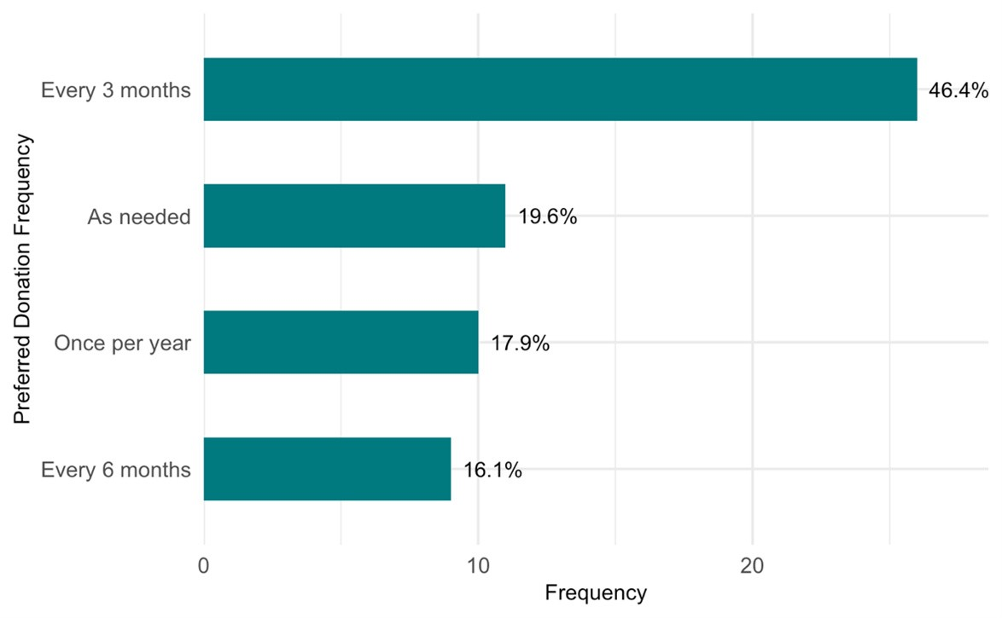
Figure S1. Preferred frequency of donations

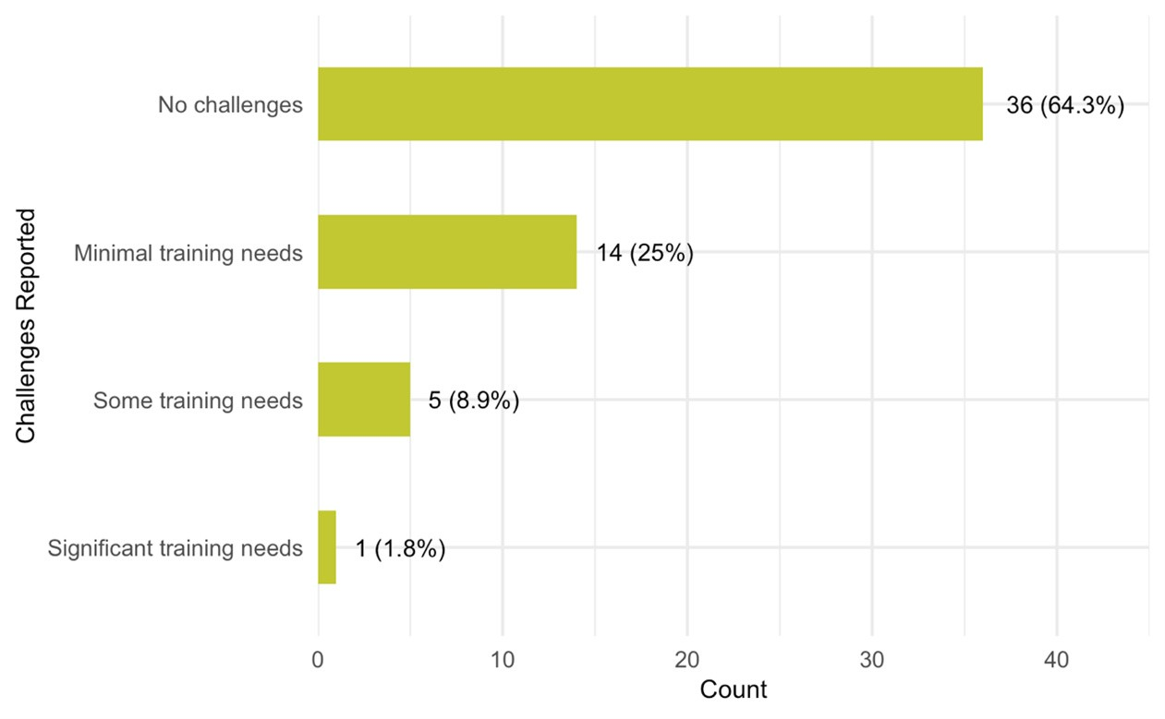

Figure S2. Distribution of challenges encountered while integrating donated equipment

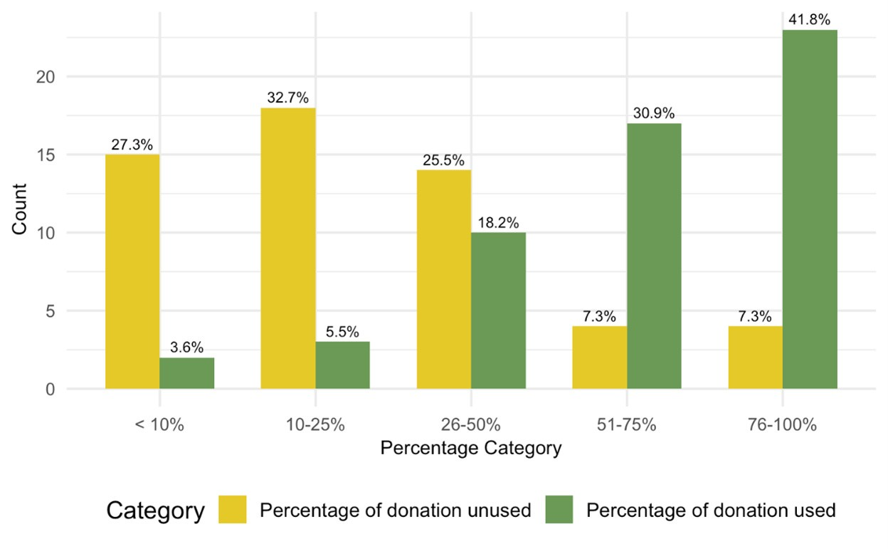

Figure S3. Distribution of Percentage of donation used versus unused

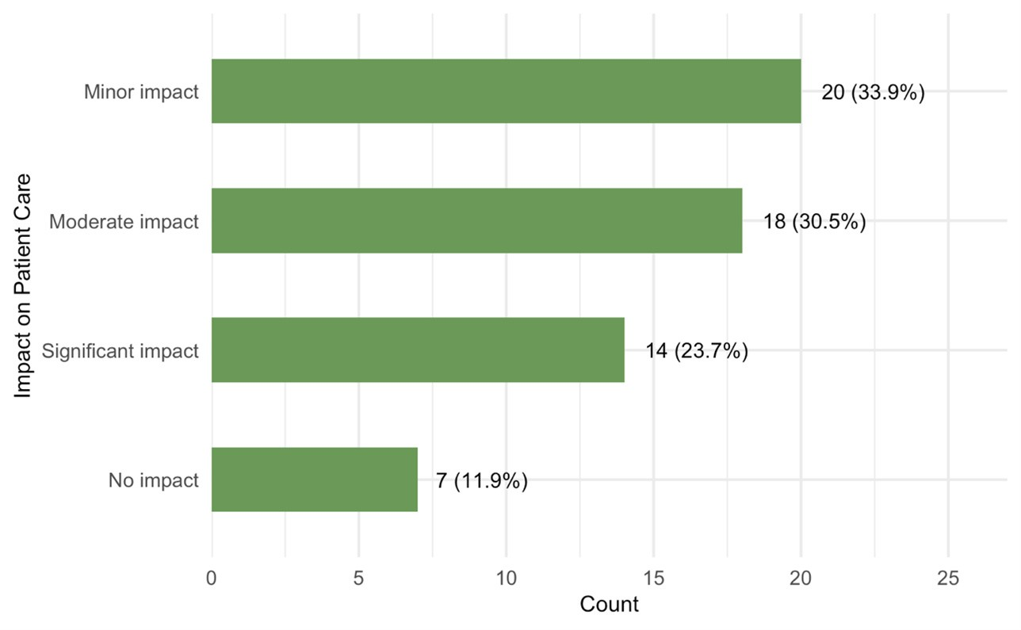

Figure S4. Distribution of impact of donated medical supplies on patient care

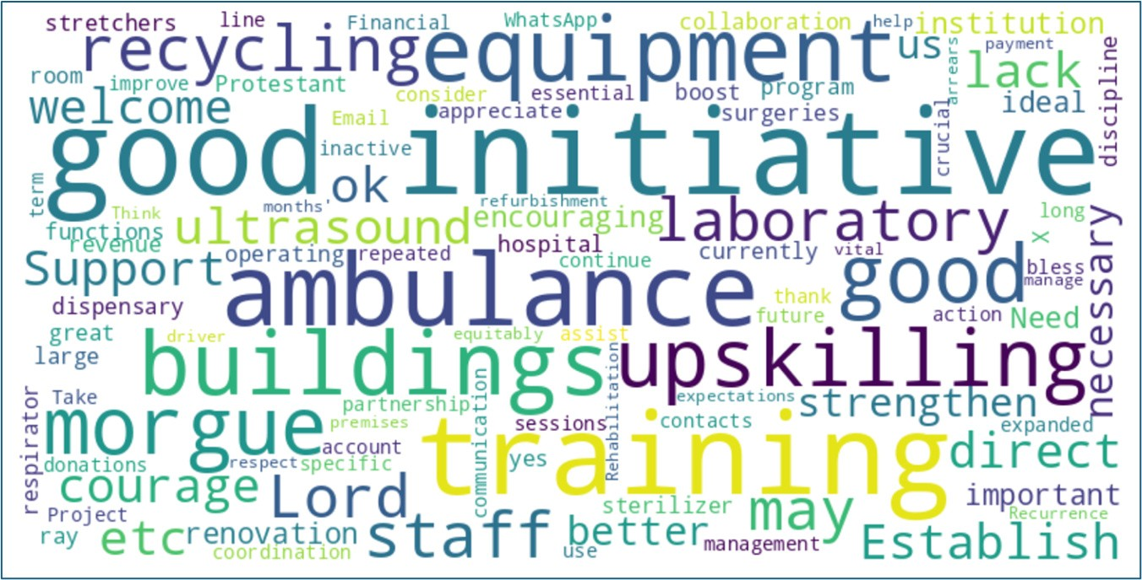

Figure S5. Wordcloud of emerging themes

SUPPLEMENTAL TABLES
Table S1. Impact of Donated Supplies on Patient Care by Department
Category | Overall (N = 59) | Administrative and Support (N = 18) | Clinical Services (N = 30) | Laboratory (N = 11) | p-value
Minor impact | 20 (33.9%) | 9 (50.0%) | 8 (26.7%) | 3 (27.3%) | 0.274
Moderate impact | 18 (30.5%) | 6 (33.3%) | 10 (33.3%) | 2 (18.2%)
No impact | 7 (11.9%) | 0 (0%) | 4 (13.3%) | 3 (27.3%)
Significant impact | 14 (23.7%) | 3 (16.7%) | 8 (26.7%) | 3 (27.3%)

Table S2. Equipment Needs by Department
Equipment Type | Overall (N = 59) | Administrative and Support (N = 18) | Clinical Services (N = 30) | Laboratory (N = 11) | p-value
Diagnostic | 49 (83.1%) | 18 (100.0%) | 23 (76.7%) | 8 (72.7%) | 0.044
Monitoring | 48 (81.4%) | 15 (83.3%) | 24 (80.0%) | 9 (81.8%) | >0.999
Treatment | 49 (83.1%) | 14 (77.8%) | 26 (86.7%) | 9 (81.8%) | 0.657
Surgical | 49 (83.1%) | 16 (88.9%) | 25 (83.3%) | 8 (72.7%) | 0.525
Other | 10 (16.9%) | 3 (16.7%) | 4 (13.3%) | 3 (27.3%) | 0.584
¹ n (%),² Fisher’s exact test

