
ONLINE SUPPLEMENTARY DOCUMENT
Appendix

Cite as: Ogunyemi KO, Lokossou VK, Sogbossi LS, Ohuabunwo C, Antara S, Senait K, Carol H, Nyenswah T, Aïssi MA, McNabb S. A pragmatic assessment of contextual fit and feasibility for e-learning implementation among public health workers in 16 West African countries: a mixed-methods study. Journal of Global Health Economics and Policy. 2024;4:e2024004.

Table of contents

Appendix 1: Good Reporting of a Mixed-Methods Study (GRAMMS) checklist…………………………. 2

Appendix 2: Pragmatic Contextual Fit and Feasibility (PCoF) tool framework…………………………... 3

Appendix 3: Pragmatic Contextual Fit and Feasibility (PCoF) tool scoring/rating system………………. 4

Appendix 4: Survey instrument (English, French, and Portuguese)………………………………………... 31

Appendix 4 Fig. 1: English survey instrument…………………………………………………………………. 13

Appendix 4 Fig. 2: French survey instrument…………………………………………………………………. 22

Appendix 4 Fig. 3: Portuguese survey instrument……………………………………………………………... 31

Appendix 5: In-depth interview guide (English and French)………………………………………………... 35

Appendix 5 Fig. 1: English in-depth interview guide………………………………………………………….. 33

Appendix 5 Fig. 2: French in-depth interview guide…………………………………………………………... 35

Appendix 6: Assumptions underlying analysis……………………………………………………………….. 36

Appendix 7: Baseline assessment of sample and sample weights computation…………………………….. 37

Appendix 7 Fig. 1: Baseline assessment of study population distribution by country to the West African public health workers population……………………………………………………………………………… 38

Appendix 8: Distribution of public health workers, gross domestic product per capita, and global health security index in West Africa ………………………………………………………………………………… 39

Appendix 9: Normality tests………………………………………………………………………………….. 40

Appendix 10: Braun & Clarke 15-point Thematic Analysis checklist…………………………………….. 41

Appendix 11: Frequency and geospatial distributions of MOT preference, acceptability, willingness to use, and workplace ICT availability………………………………………………………………………. 57

Appendix 11 Table 1: Frequency distribution of MOT preference………………………………………….... 44

Appendix 11 Fig. 1: Geospatial distribution of MOT preference…………………………………………….. 45

Appendix 11 Table 2: Frequency distribution of MOT acceptability…………………………………………. 48

Appendix 11 Fig. 2: Geospatial distribution of MOT acceptability…………………………………………... 49

Appendix 11 Table 3: Frequency distribution of MOT willingness to use…………………………………… 52

Appendix 11 Fig. 3: Geospatial distribution of MOT willingness to use…………………………………….. 53

Appendix 11 Table 4: Frequency distribution of MOT workplace ICT availability…………………………. 56

Appendix 11 Fig. 4: Geospatial distribution of MOT workplace ICT availability………………………….. 57

Appendix 1. Good Reporting of a Mixed-Methods Study (GRAMMS) checklist

Guideline | Section: Page
Justification to use a mixed methods approach to the research question | Methods p. 6
Articulation of the design in terms of purpose, priority, and sequence of methods | Methods p. 6-9
Describe each method in terms of sampling, data collection and analysis | Methods p. 6-9
Delineate where and how integration occurs and who has participated in it | Methods p. 7, 9  Figure 2 (manuscript)
Describe any limitation of one method associated with the presence of another | Discussion p. 17
Describe insights gained from mixing or integrating methods | Findings p. 10-14  Discussion p. 14-17

Reference
1. O’Cathain A, Murphy E, Nicholl J. The quality of mixed methods studies in health services research. J Health Serv Res Policy. 2008;13(2):92-8.

Appendix 2. Pragmatic Contextual Fit and Feasibility (PCoF) tool framework

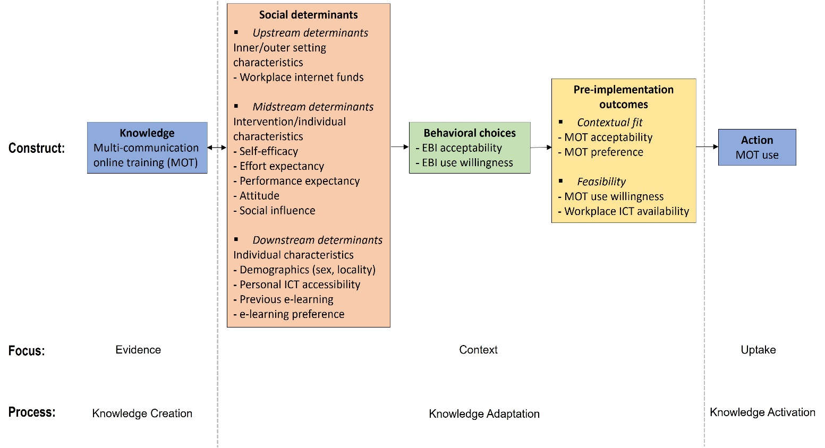

Appendix 3. Pragmatic Contextual Fit and Feasibility (PCoF) tool scoring/rating system

 | Acceptability  Rate | Preference  Rate | Willingness to Use  Rate | Resource Availability  Rate | RANKING  score (rank)
CONTEXTUAL FIT | High | High | – | – | 3 (strong fit)
CONTEXTUAL FIT | High | Low | – | – | 2 (somewhat fit)
CONTEXTUAL FIT | Low | High | – | – | 2 (somewhat fit)
CONTEXTUAL FIT | Moderate | Moderate | – | – | 2 (somewhat fit)
CONTEXTUAL FIT | Moderate | High | – | – | 2 (somewhat fit)
CONTEXTUAL FIT | High | Moderate | – | – | 2 (somewhat fit)
CONTEXTUAL FIT | Moderate | Low | – | – | 2 (somewhat fit)
CONTEXTUAL FIT | Low | Moderate | – | – | 2 (somewhat fit)
CONTEXTUAL FIT | Low | Low | – | – | 1 (weak fit)
FEASIBILITY | – | – | High | High | 3 (strong feasibility)
FEASIBILITY | – | – | High | Low | 2 (somewhat feasibility)
FEASIBILITY | – | – | Low | High | 2 (somewhat feasibility)
FEASIBILITY | – | – | Moderate | Moderate | 2 (somewhat feasibility)
FEASIBILITY | – | – | Moderate | High | 2 (somewhat feasibility)
FEASIBILITY | – | – | High | Moderate | 2 (somewhat feasibility)
FEASIBILITY | – | – | Moderate | Low | 2 (somewhat feasibility)
FEASIBILITY | – | – | Low | Moderate | 2 (somewhat feasibility)
FEASIBILITY | – | – | Low | Low | 1 (weak feasibility)
– denotes not applicable.

Appendix 4. Survey instrument (English, French, and Portuguese)

Appendix 4 Fig. 1. English survey instrument

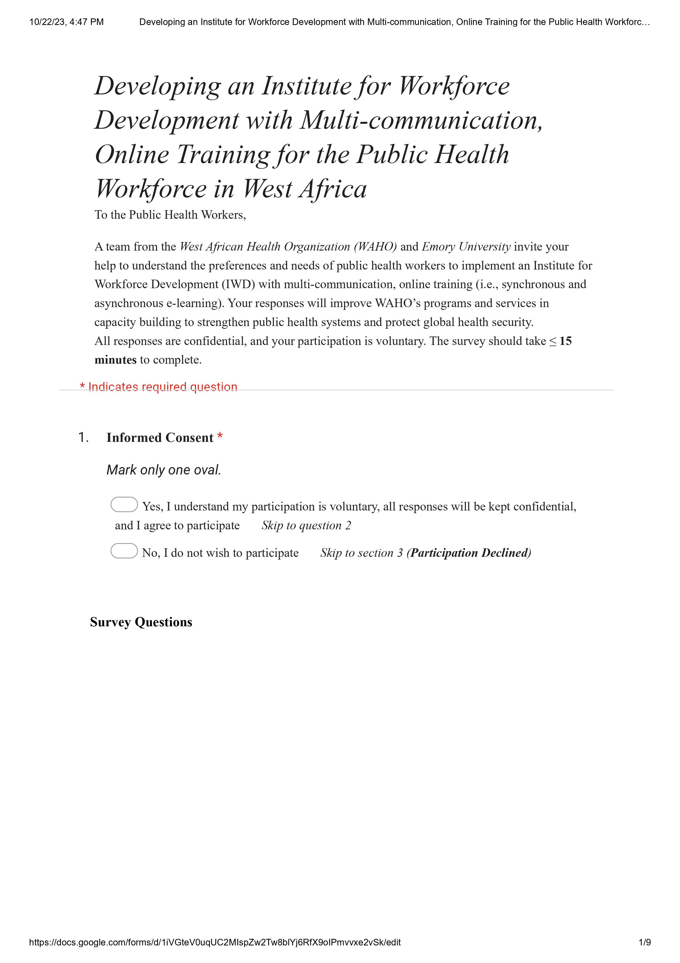
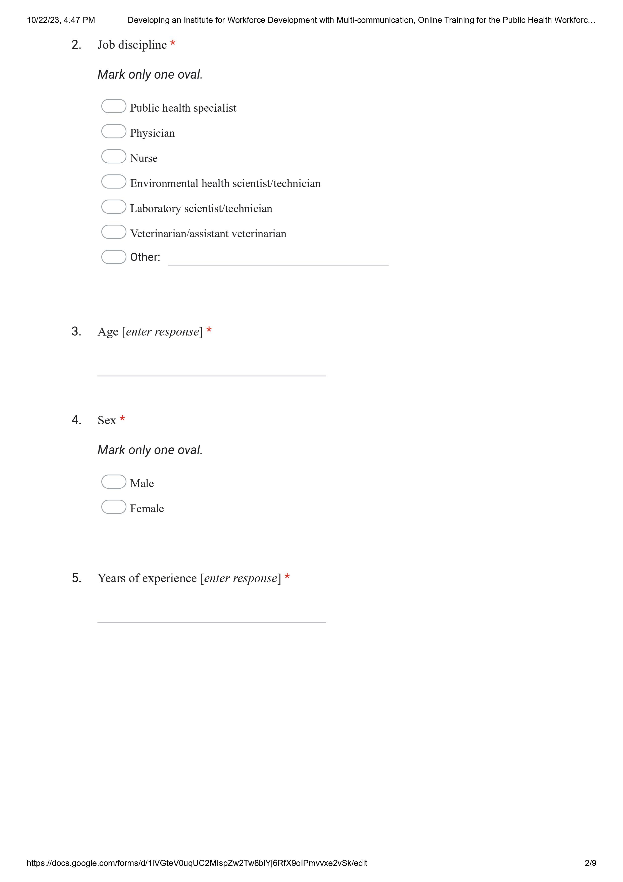

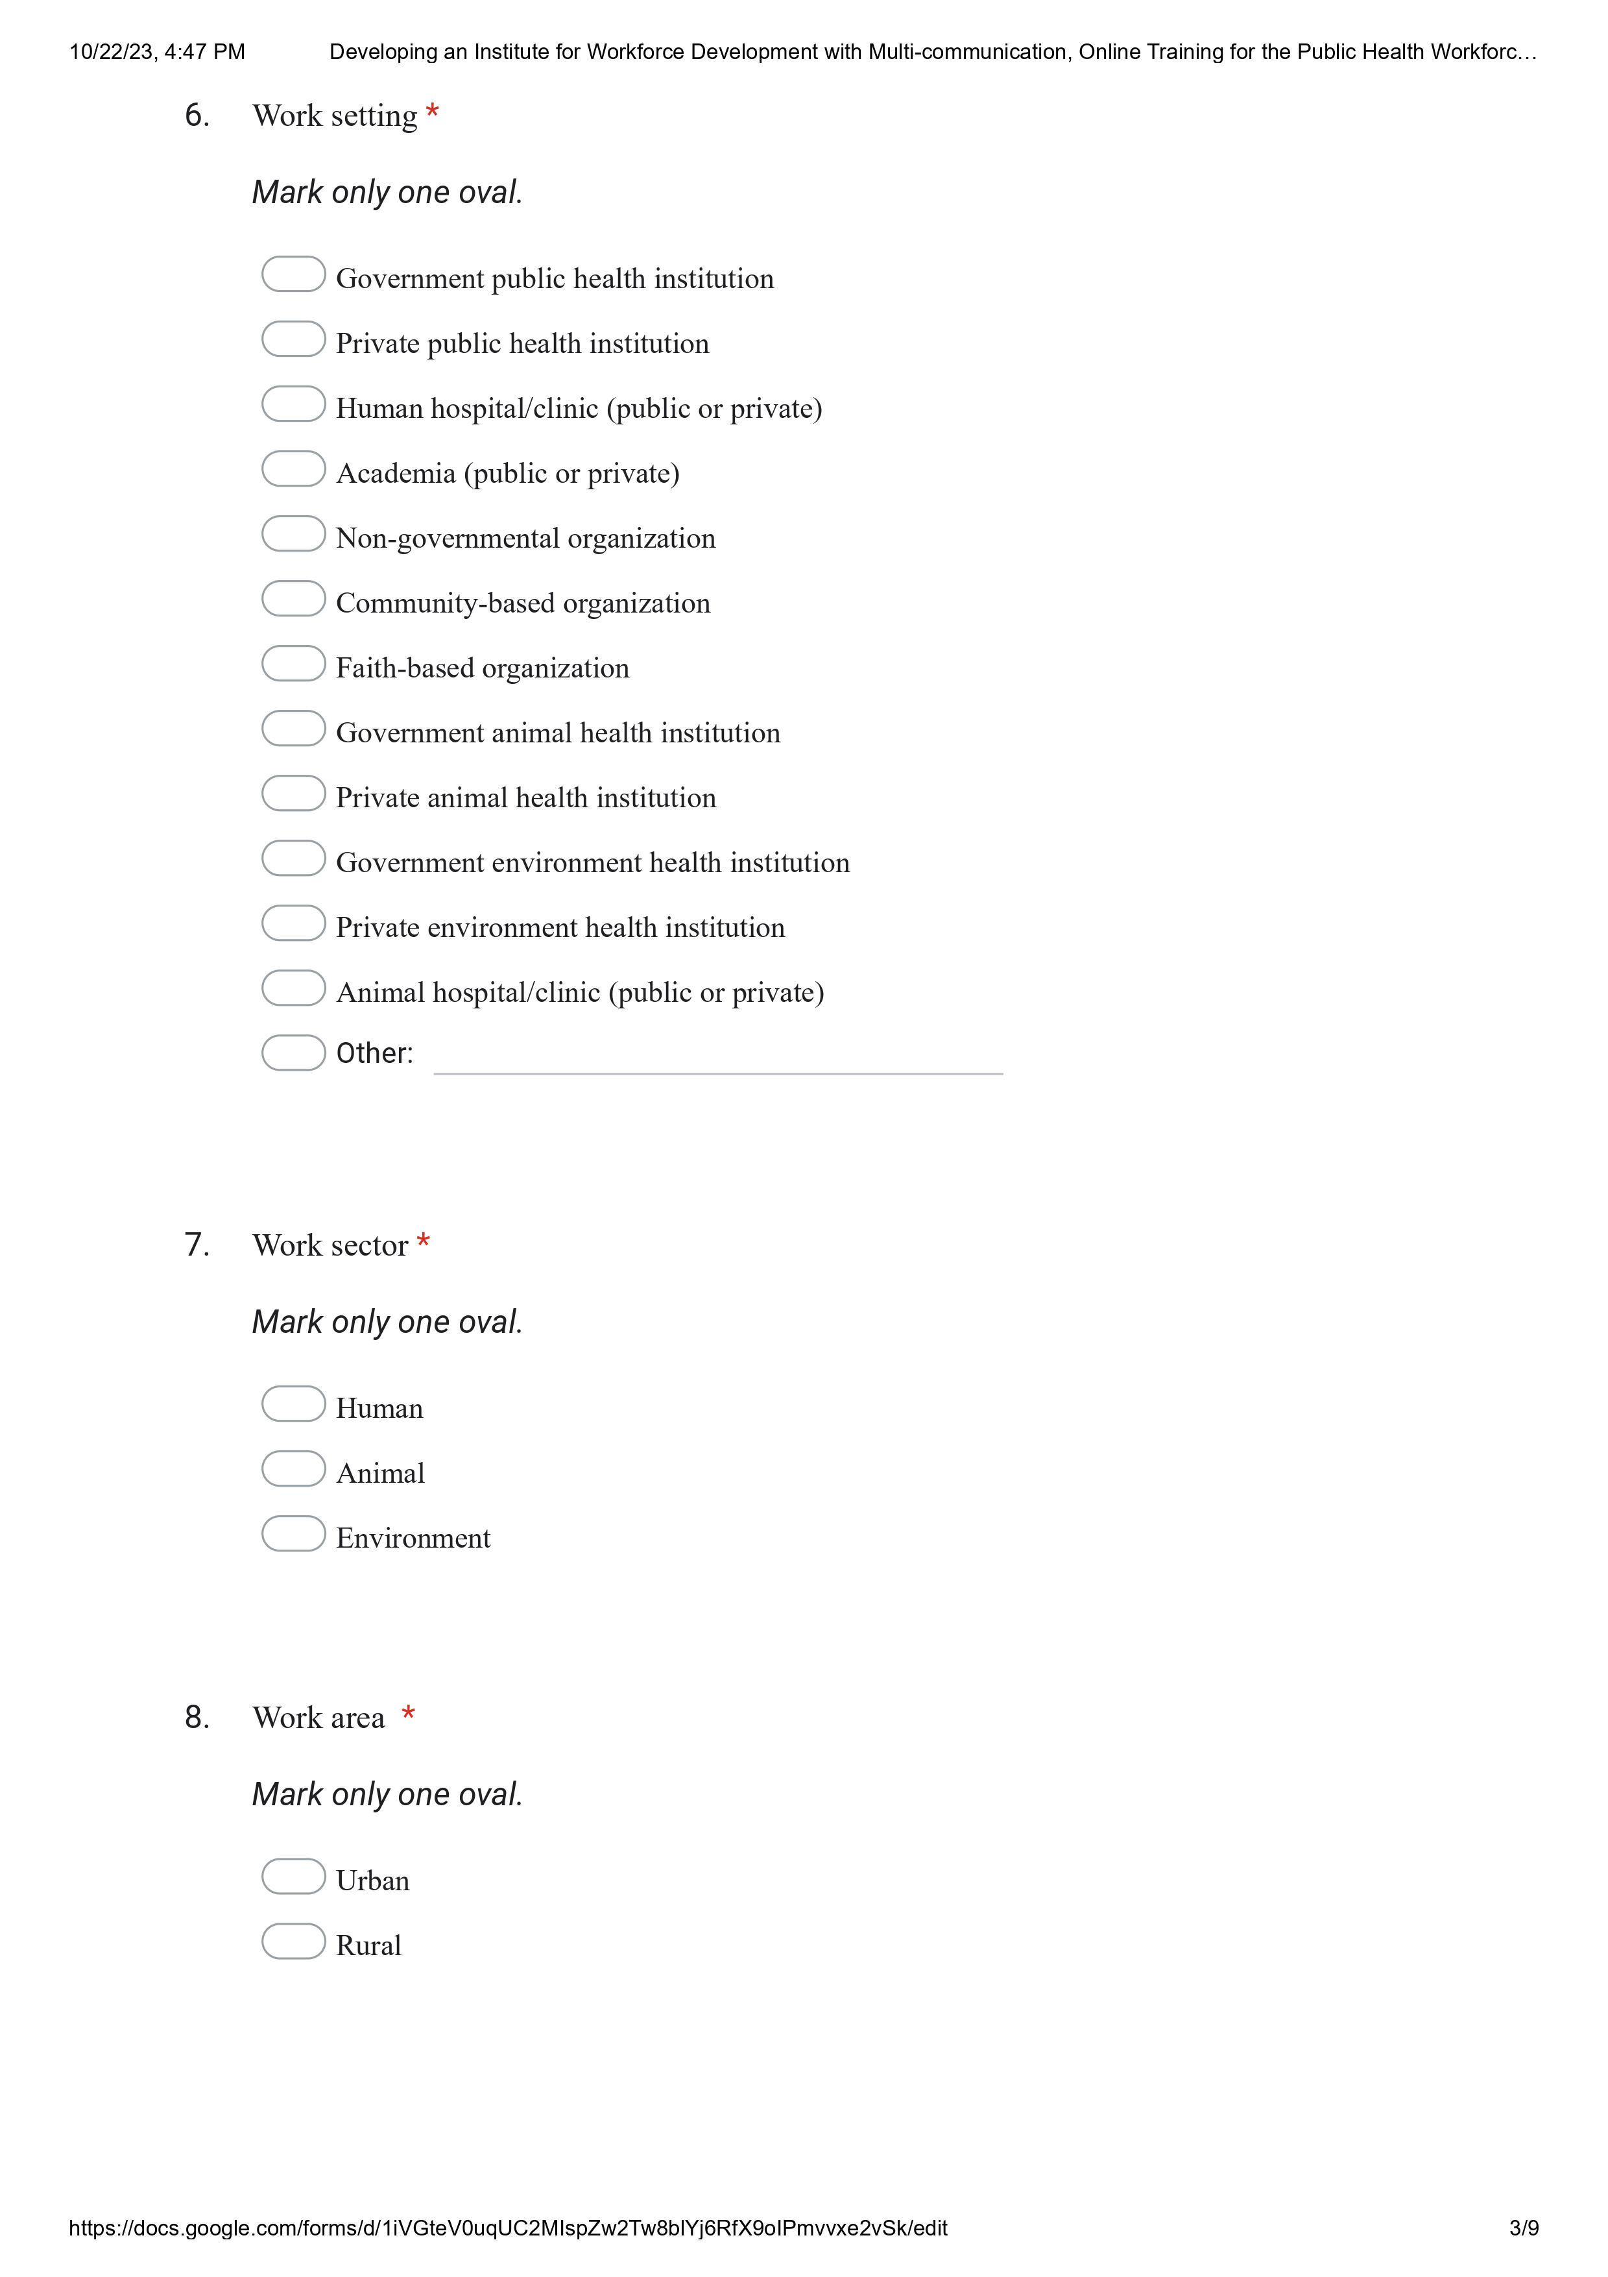

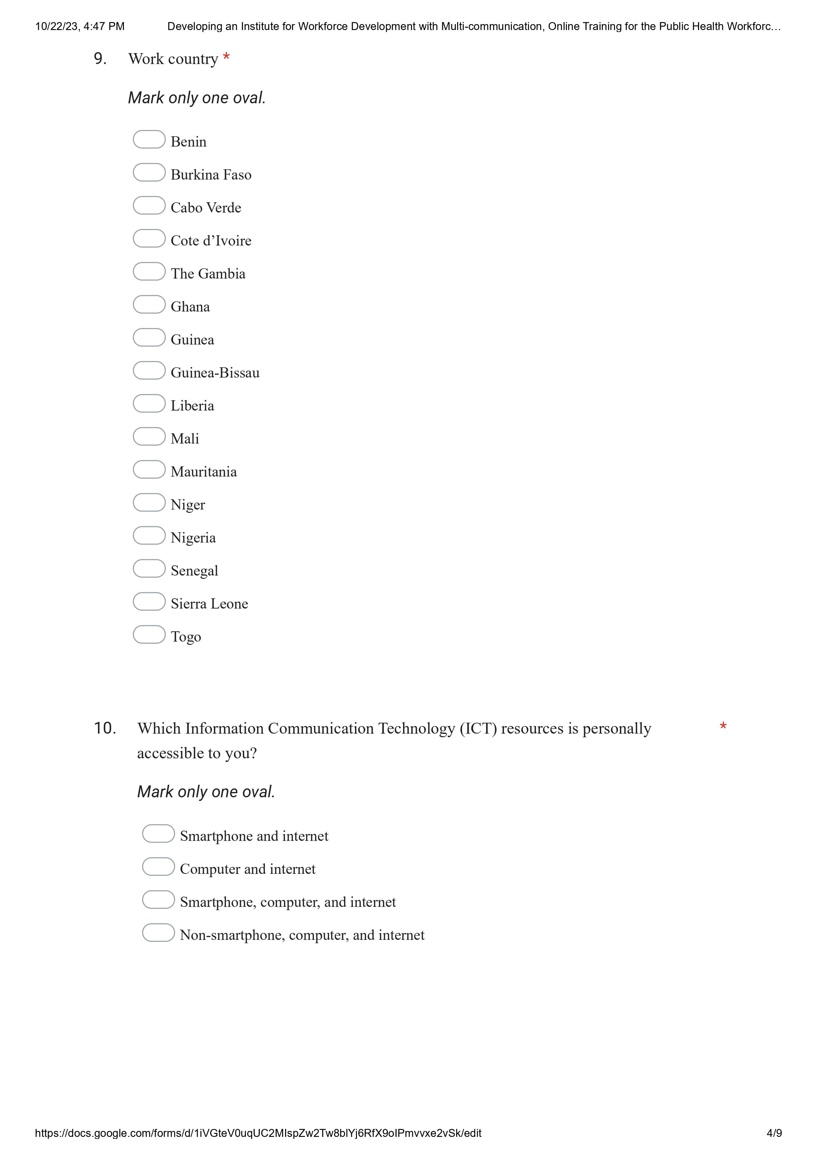

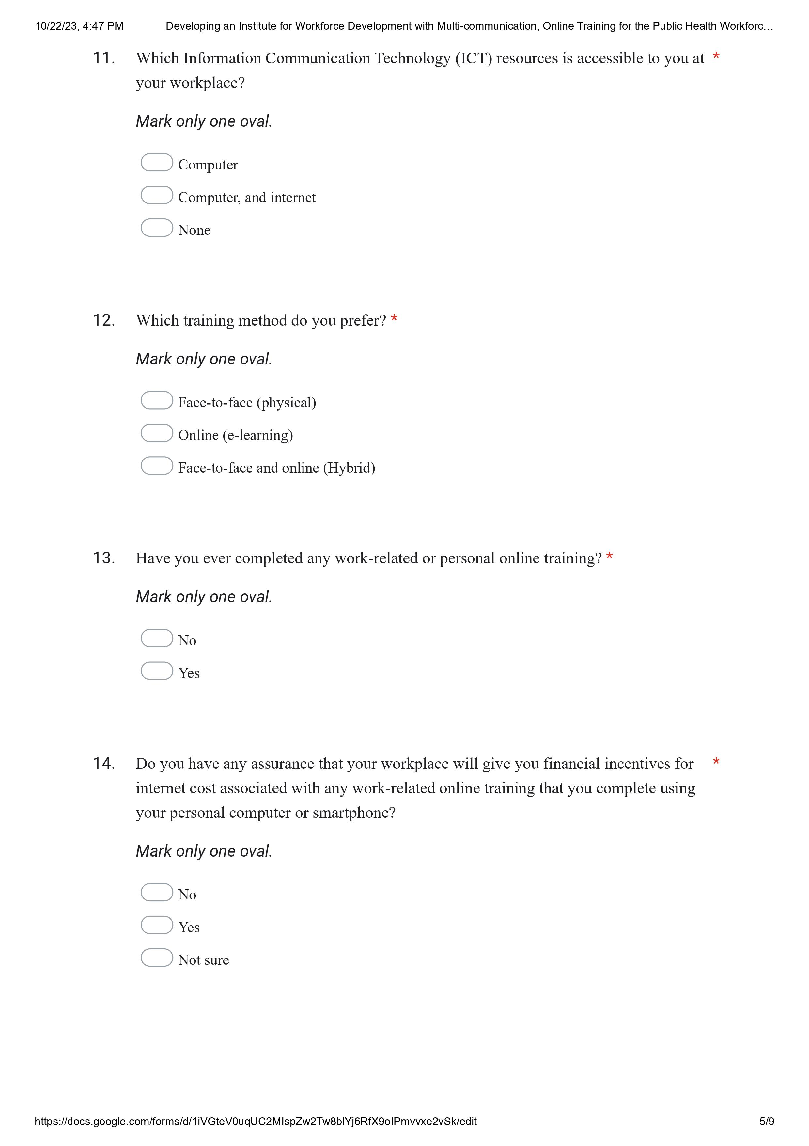

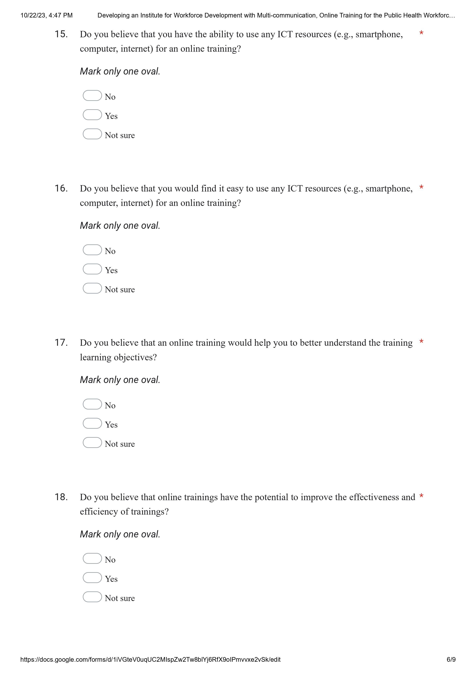

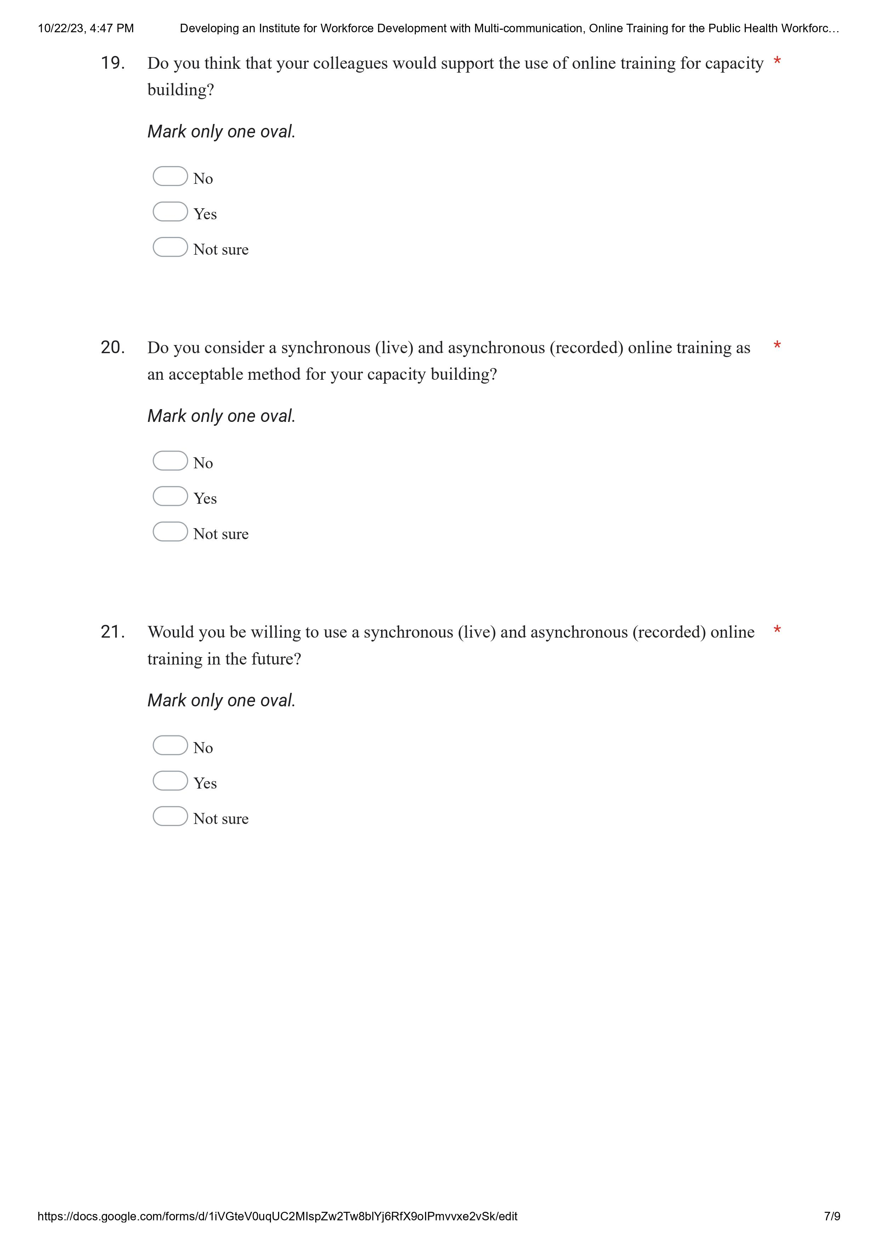

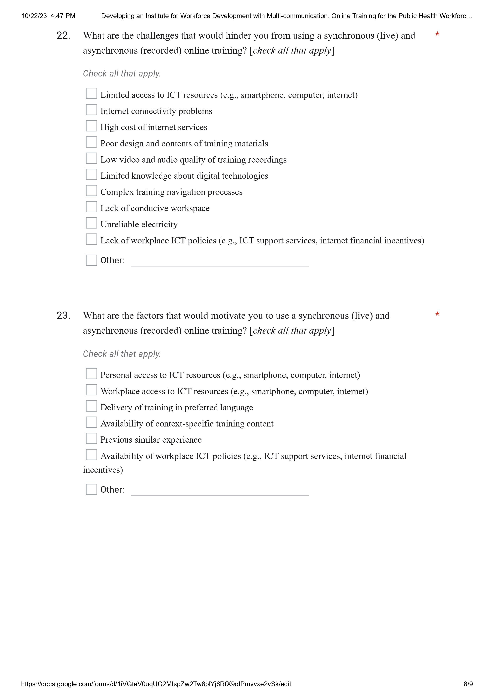



Appendix 4 Fig. 2. French survey instrument

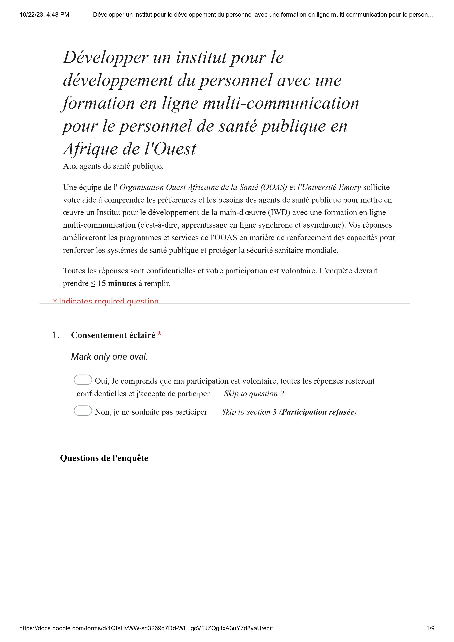

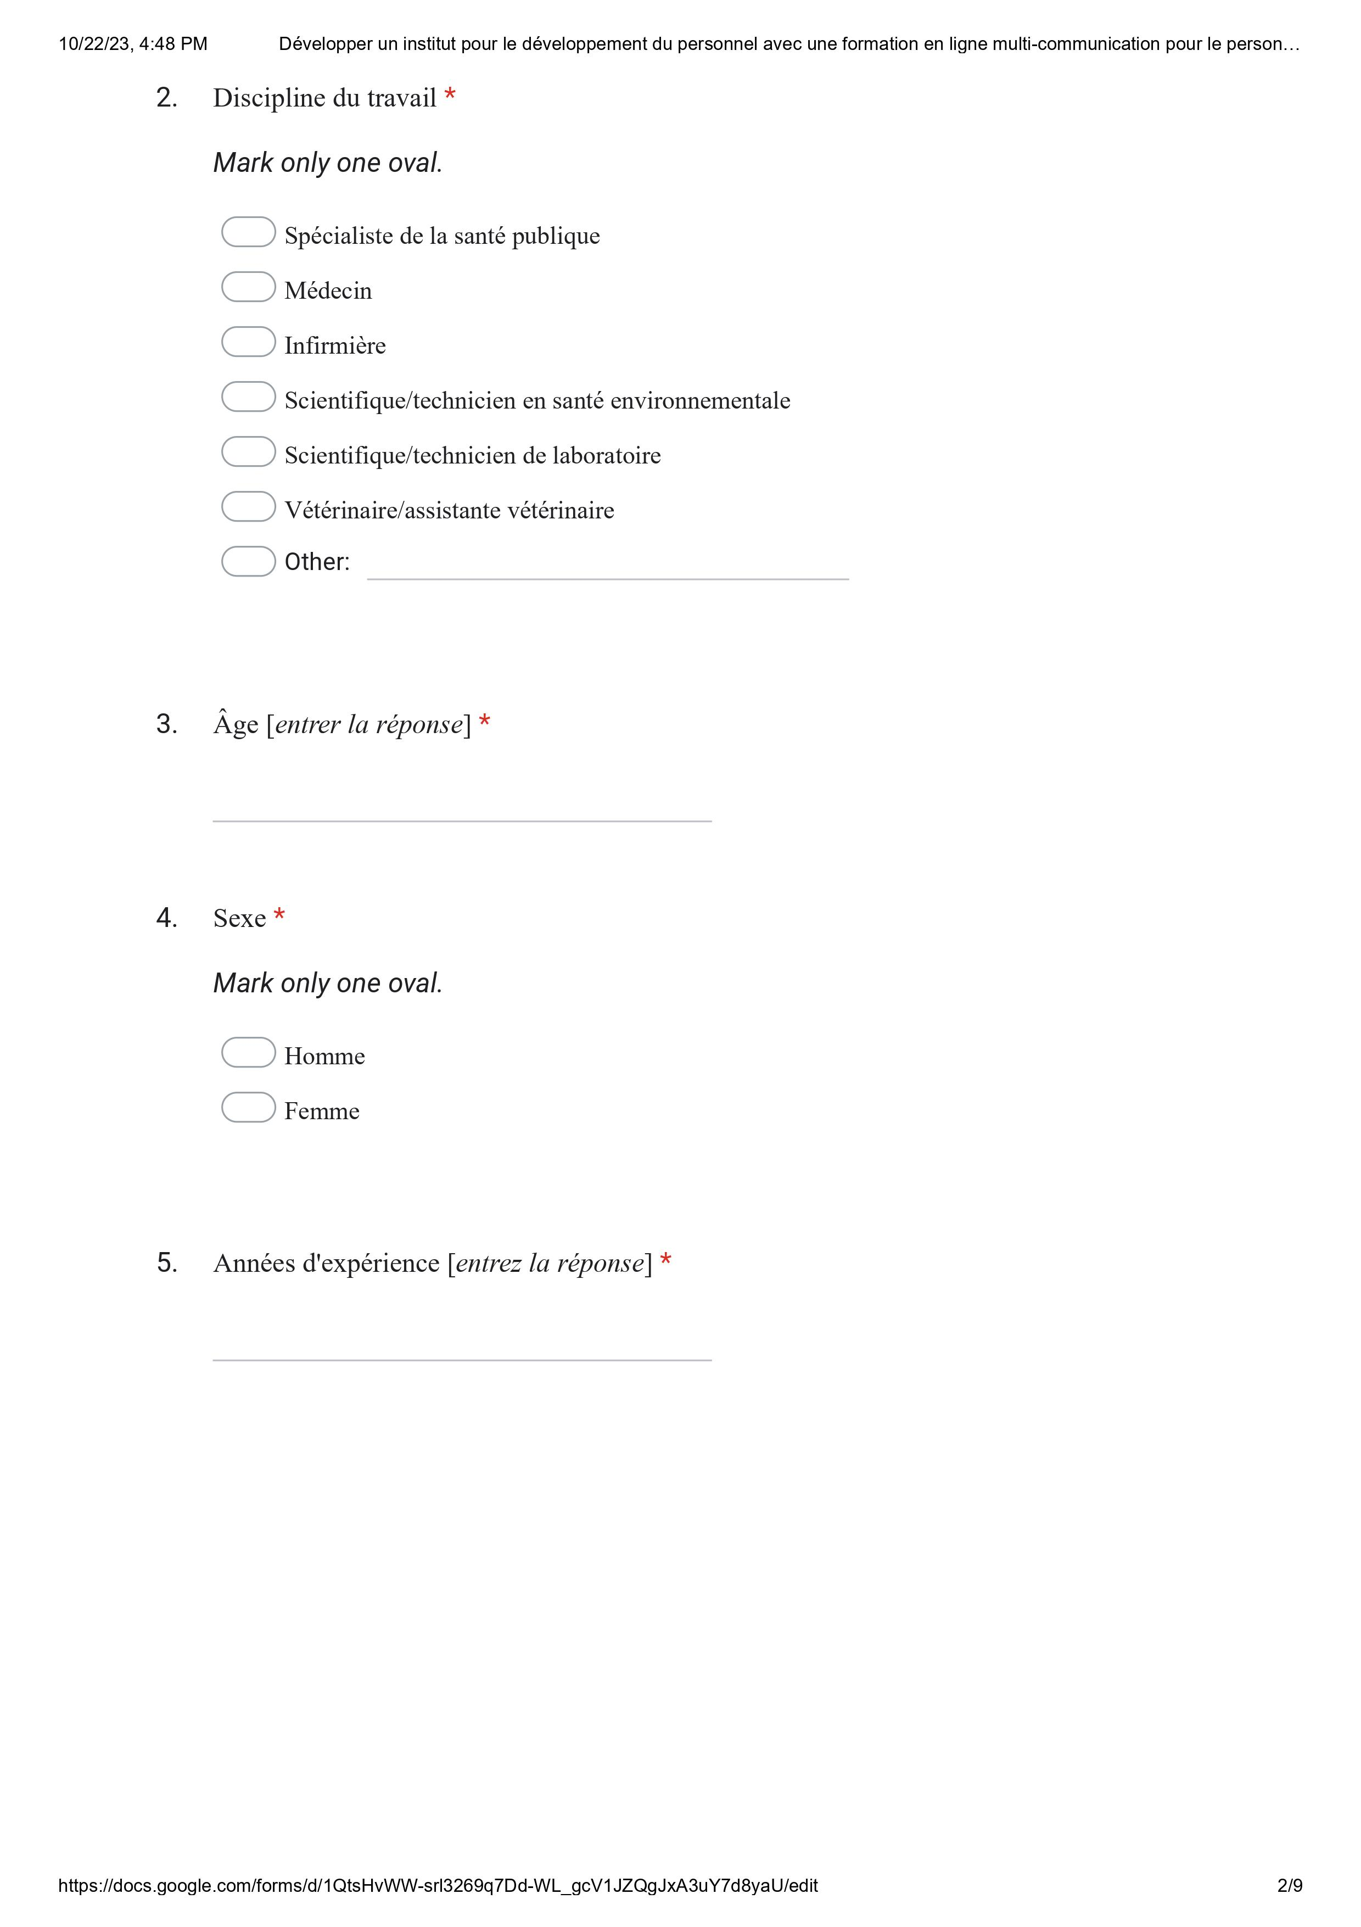

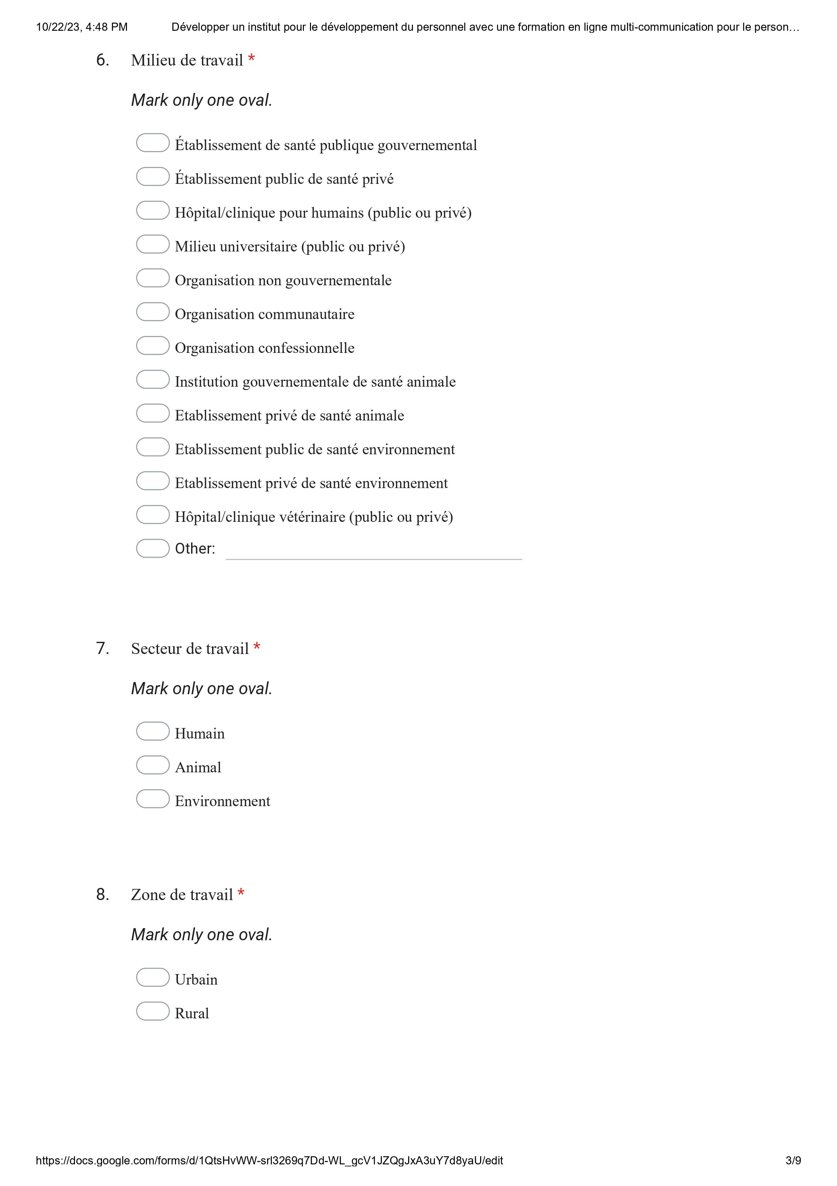

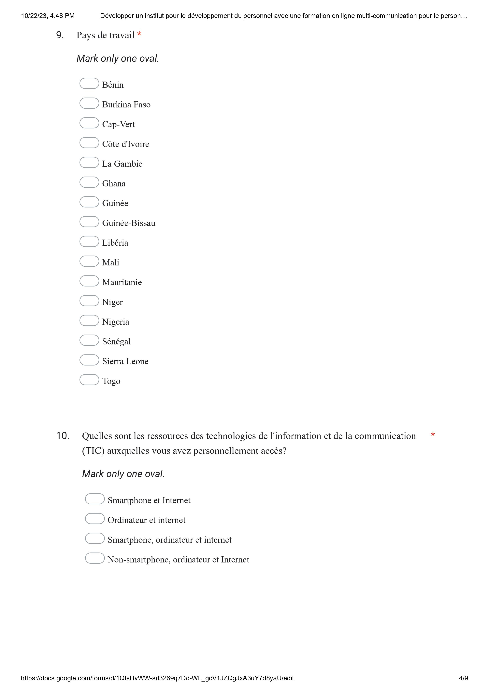

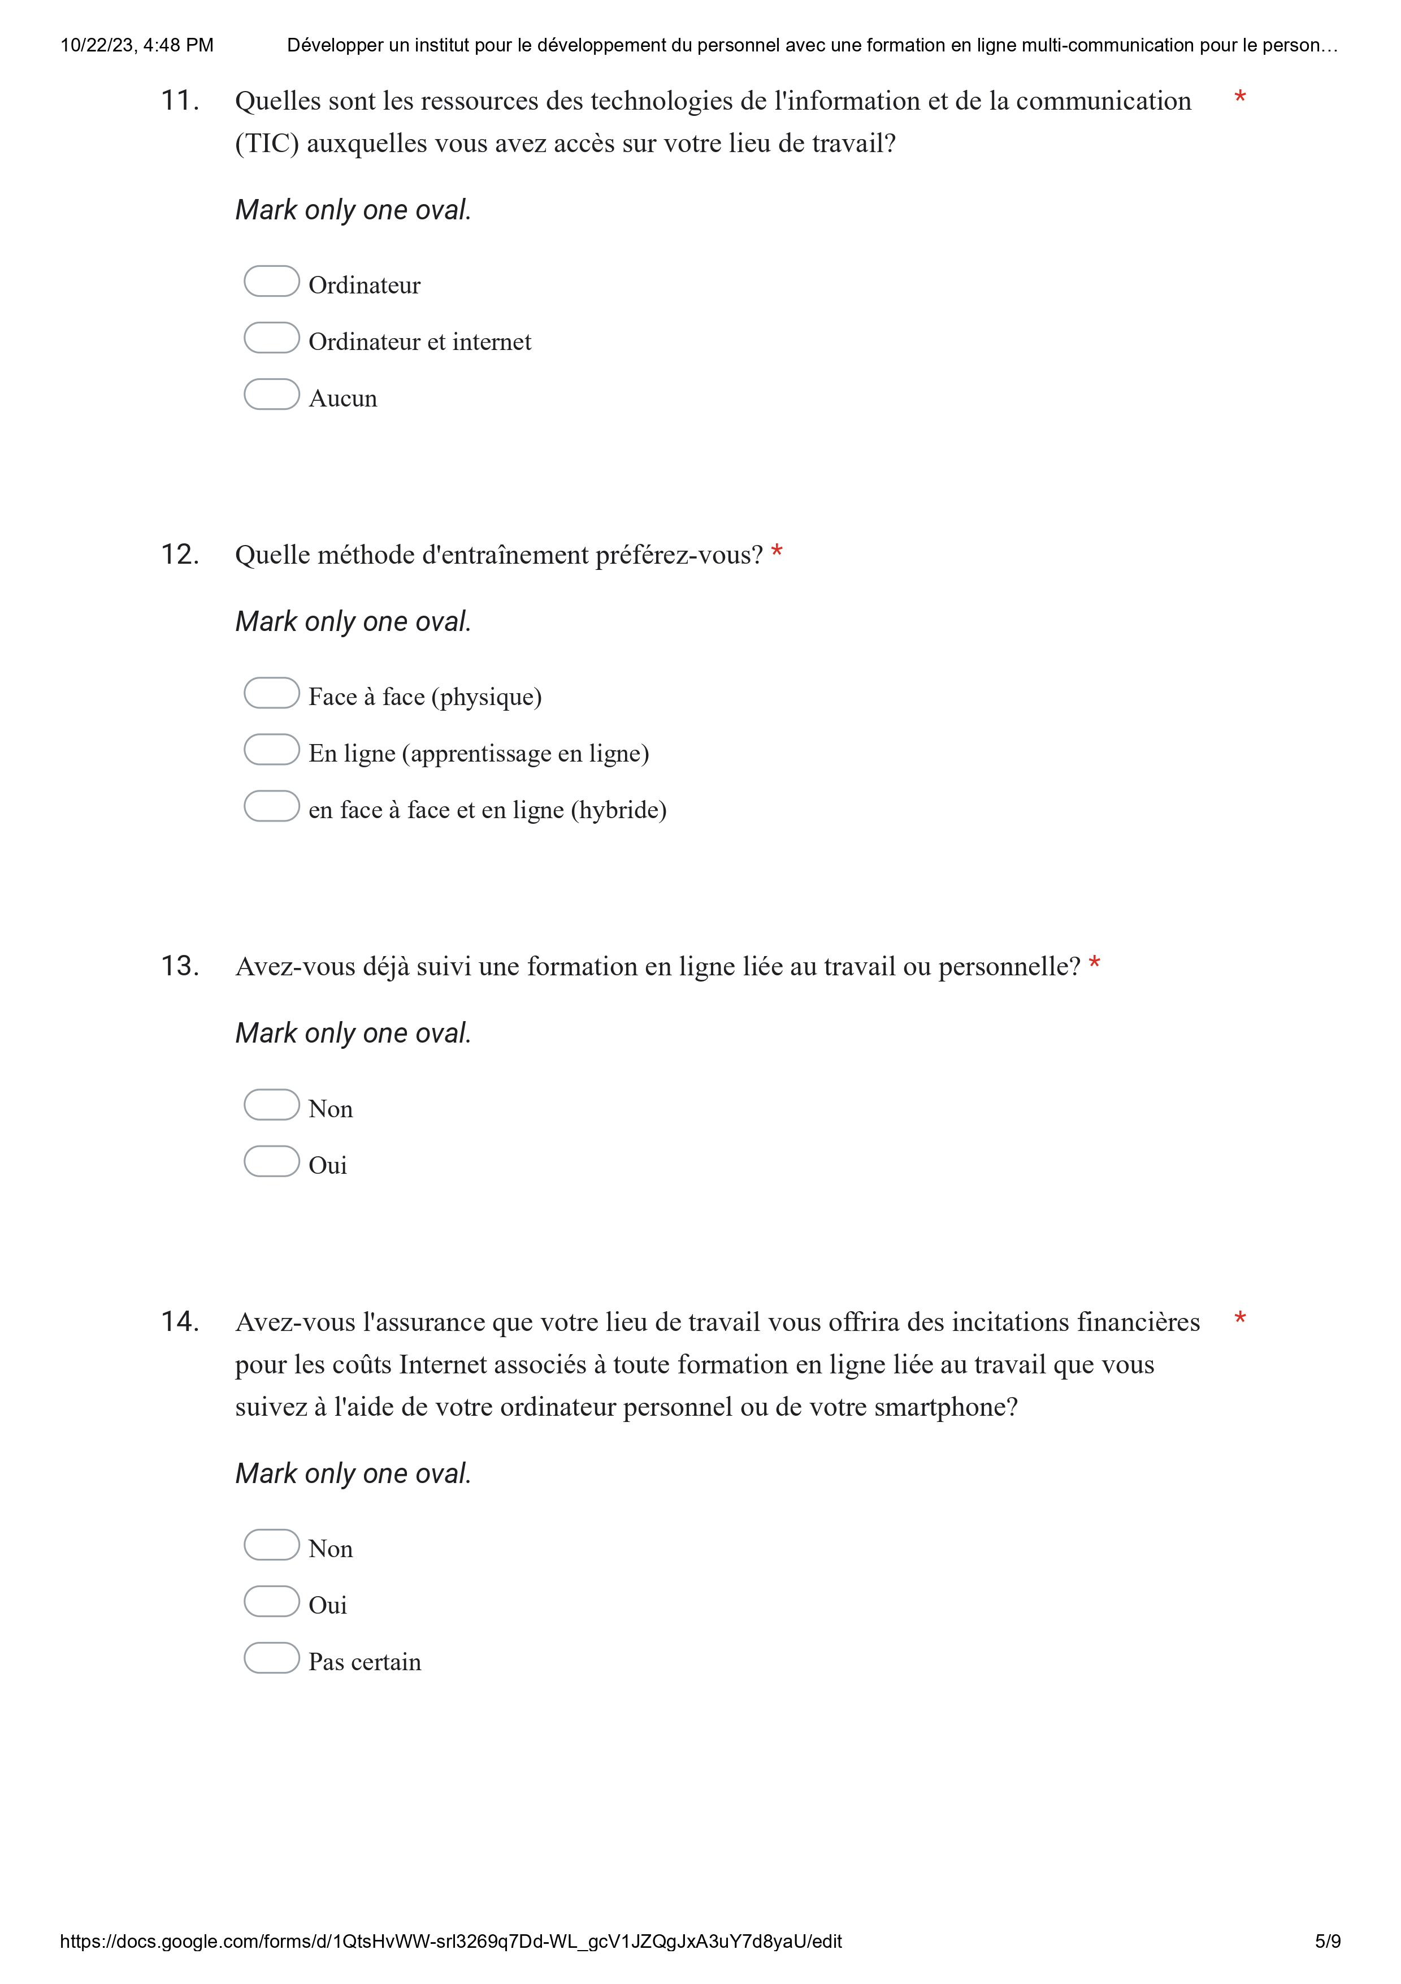

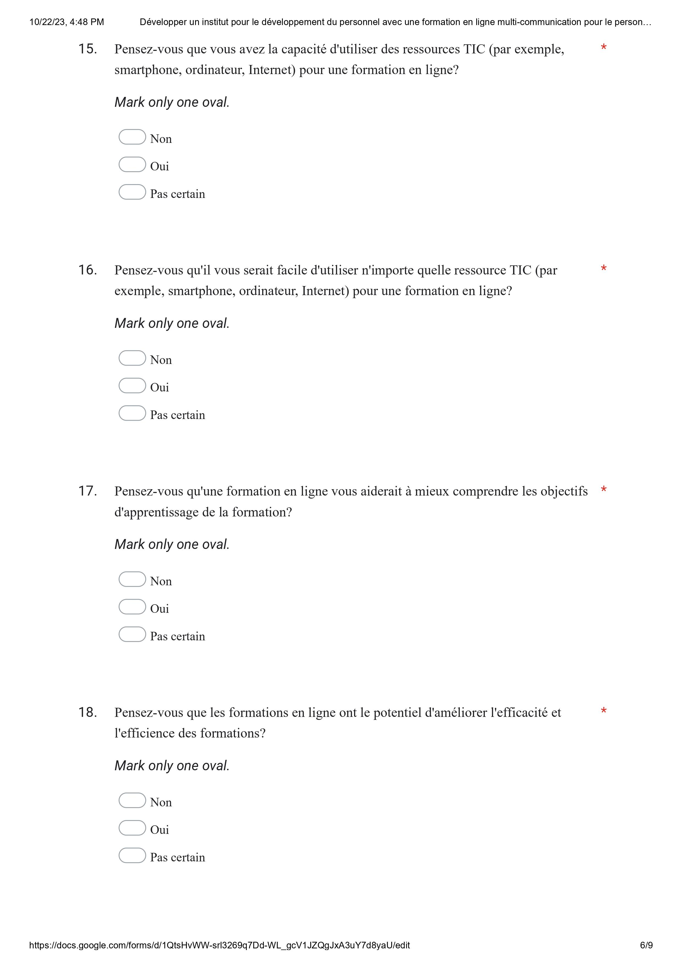

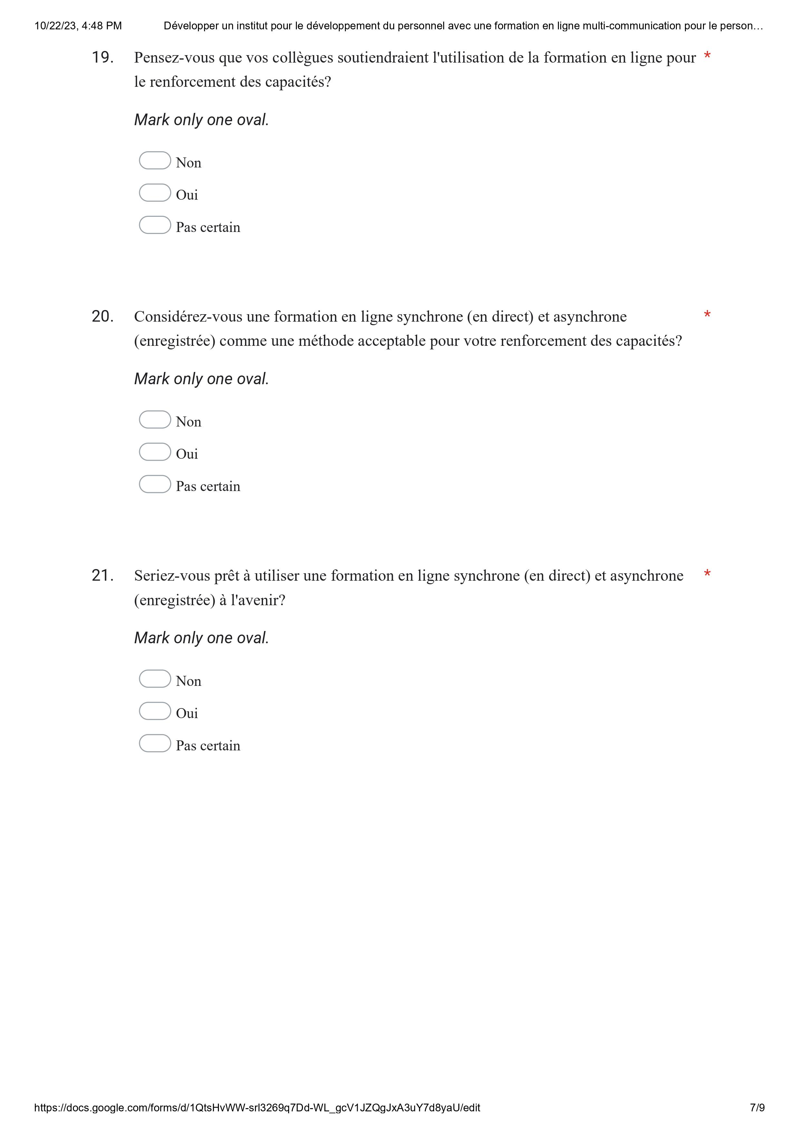

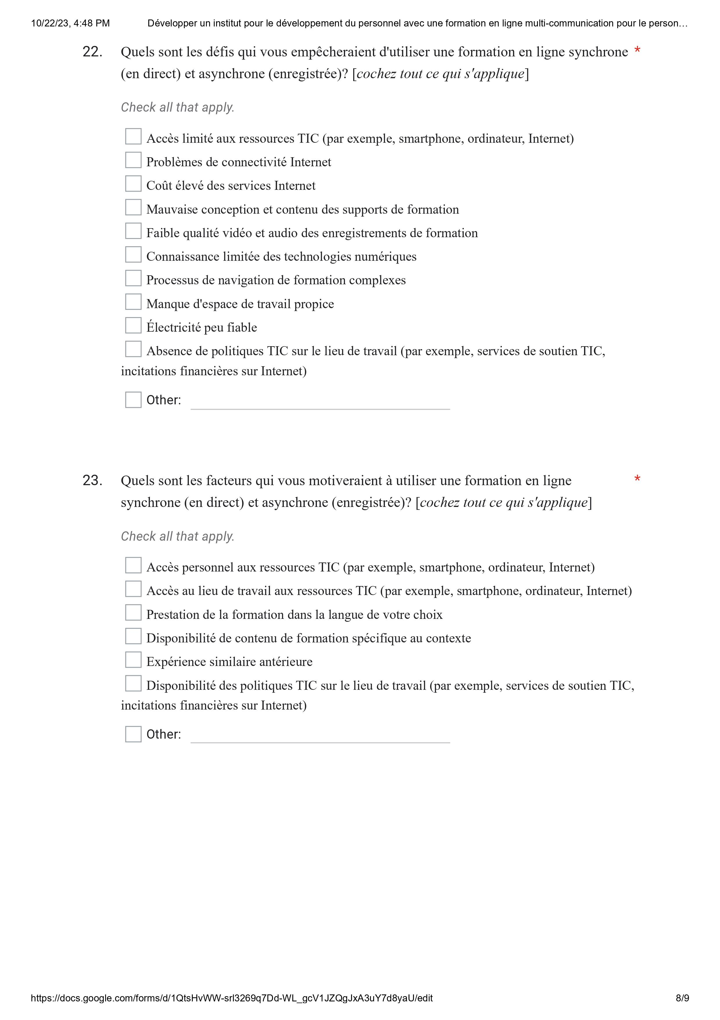



Appendix 4 Fig. 3. Portuguese survey instrument

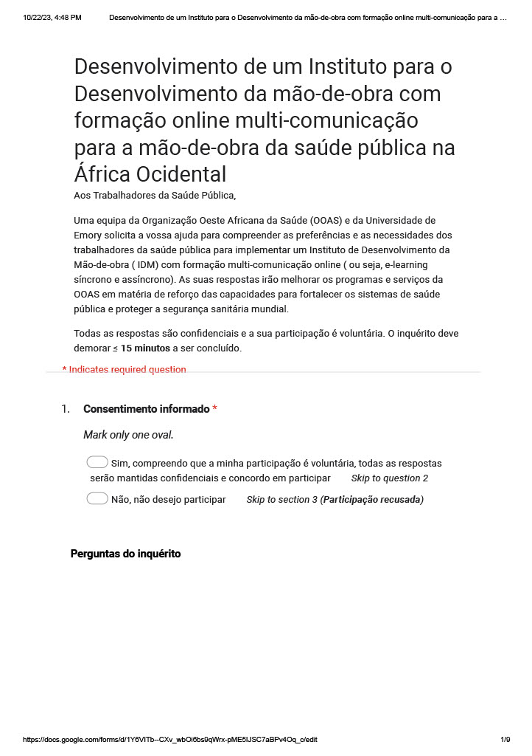

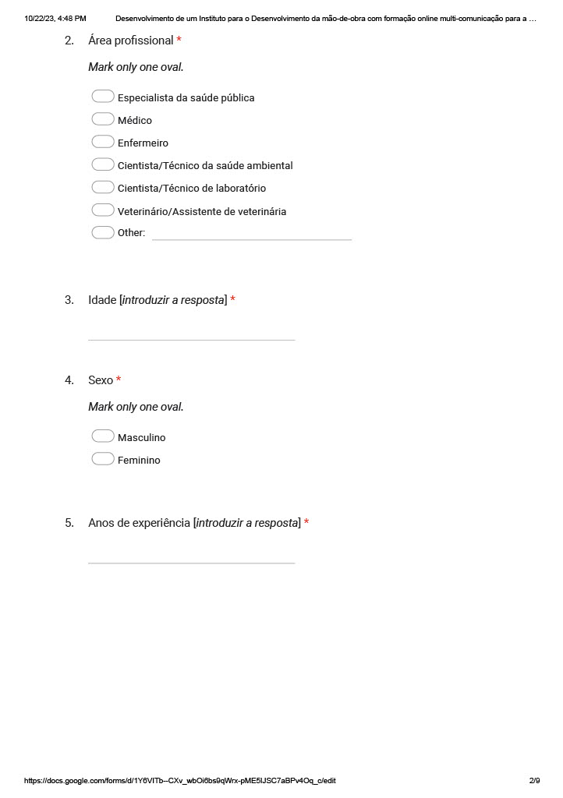

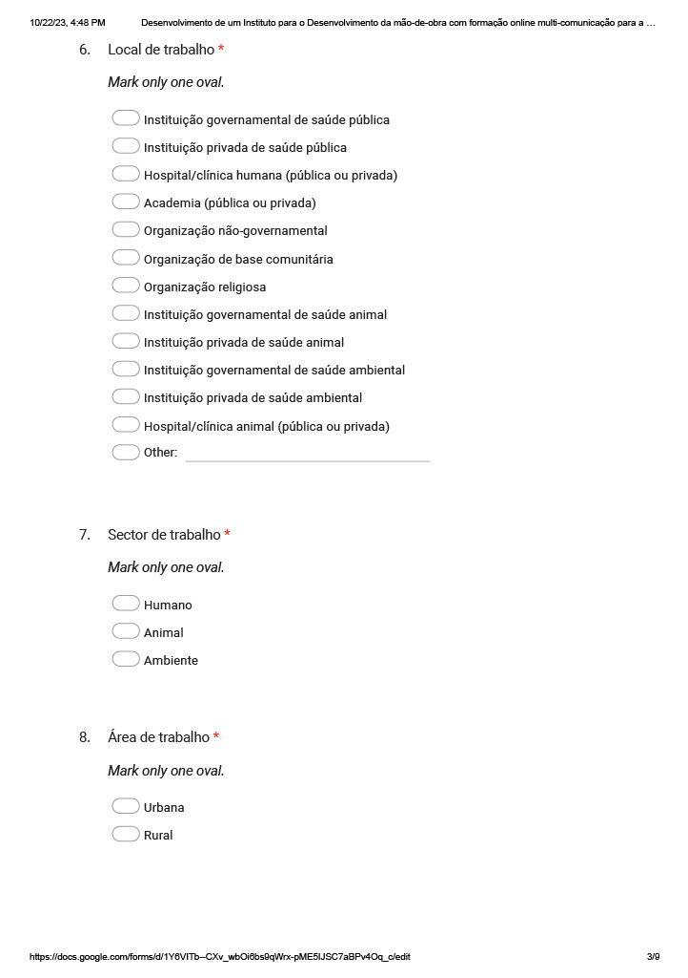

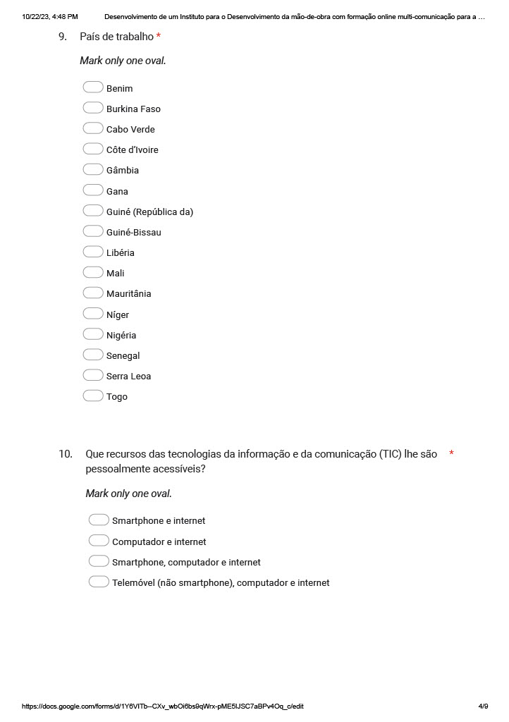

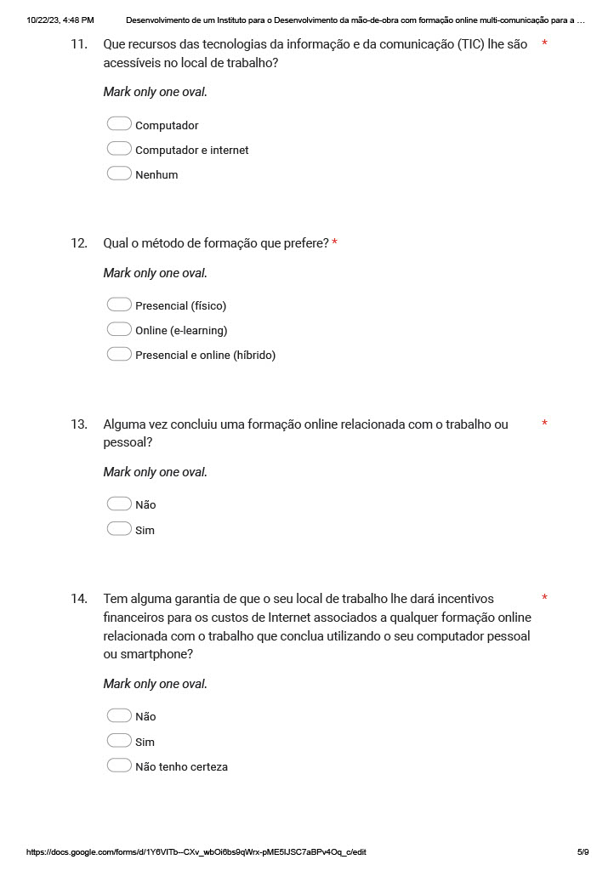

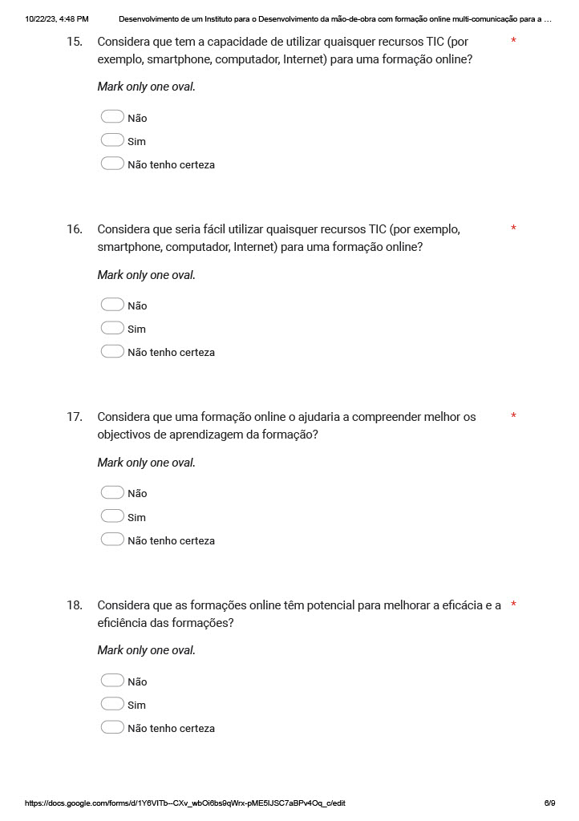

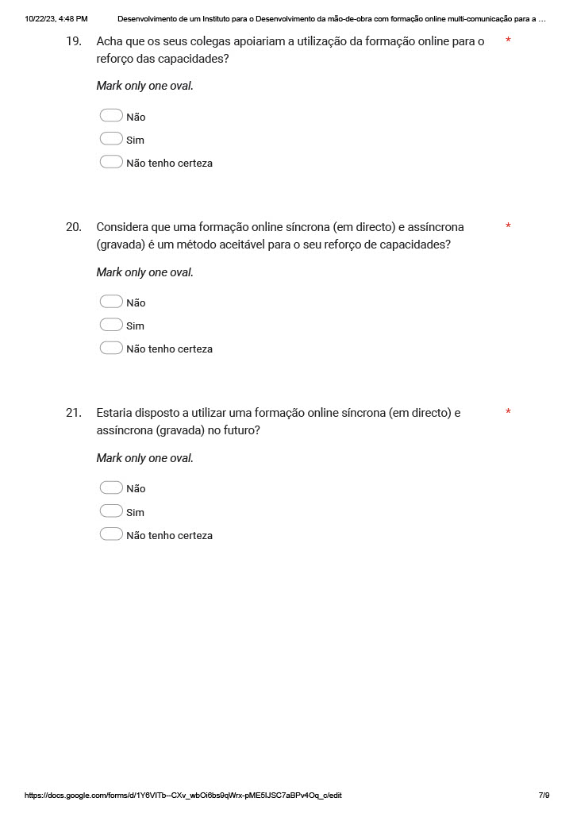

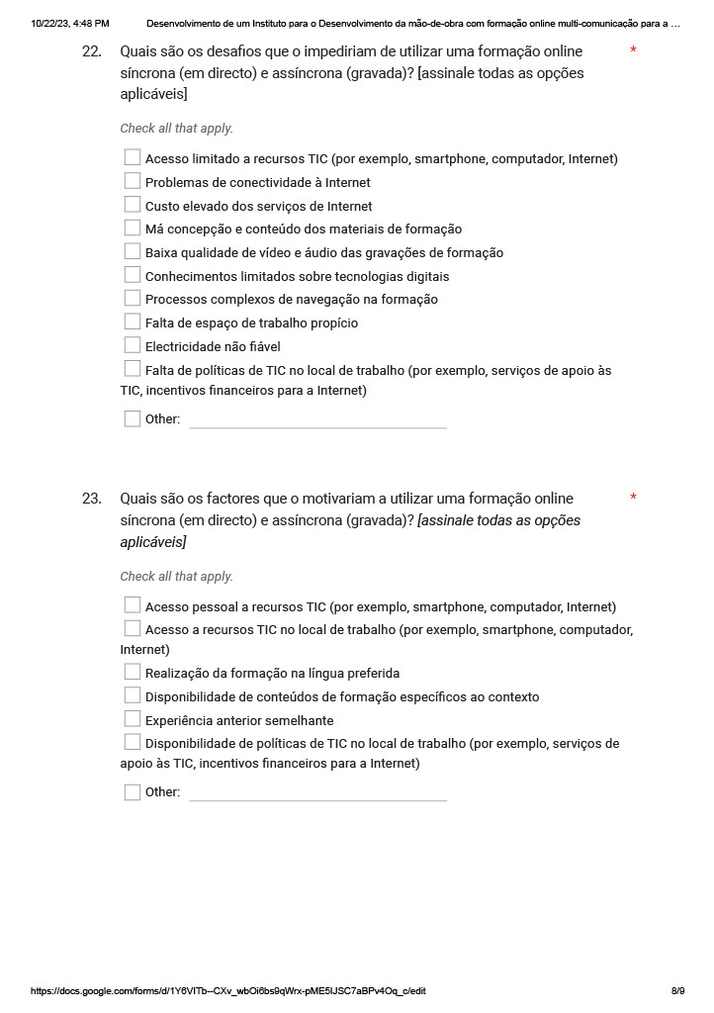

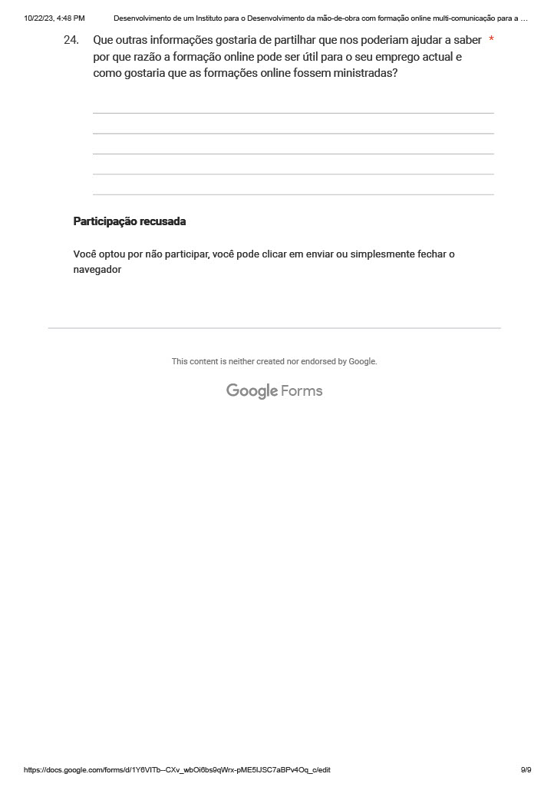

Appendix 5. In-depth interview guide (English and French)

Appendix 5 Fig. 1. English in-depth interview guide




Appendix 5 Fig. 2. French in-depth interview guide

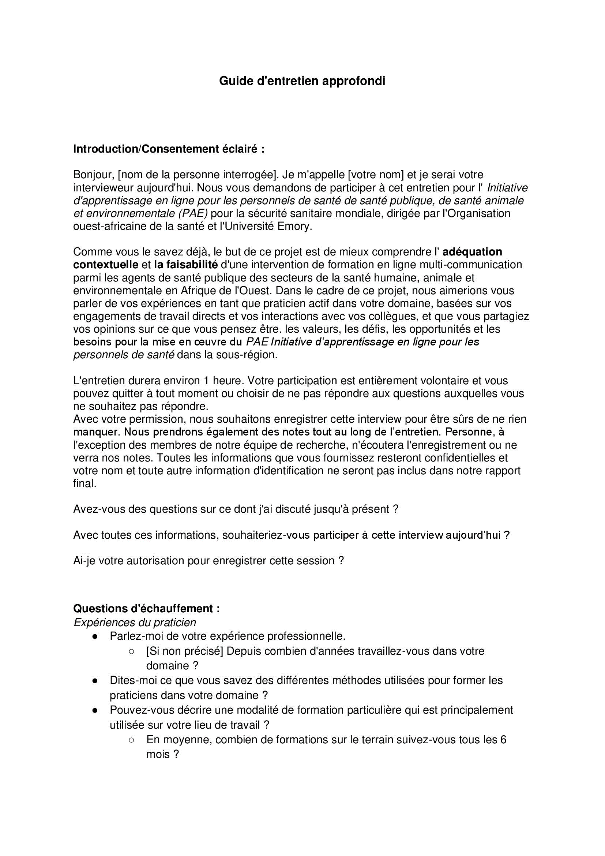

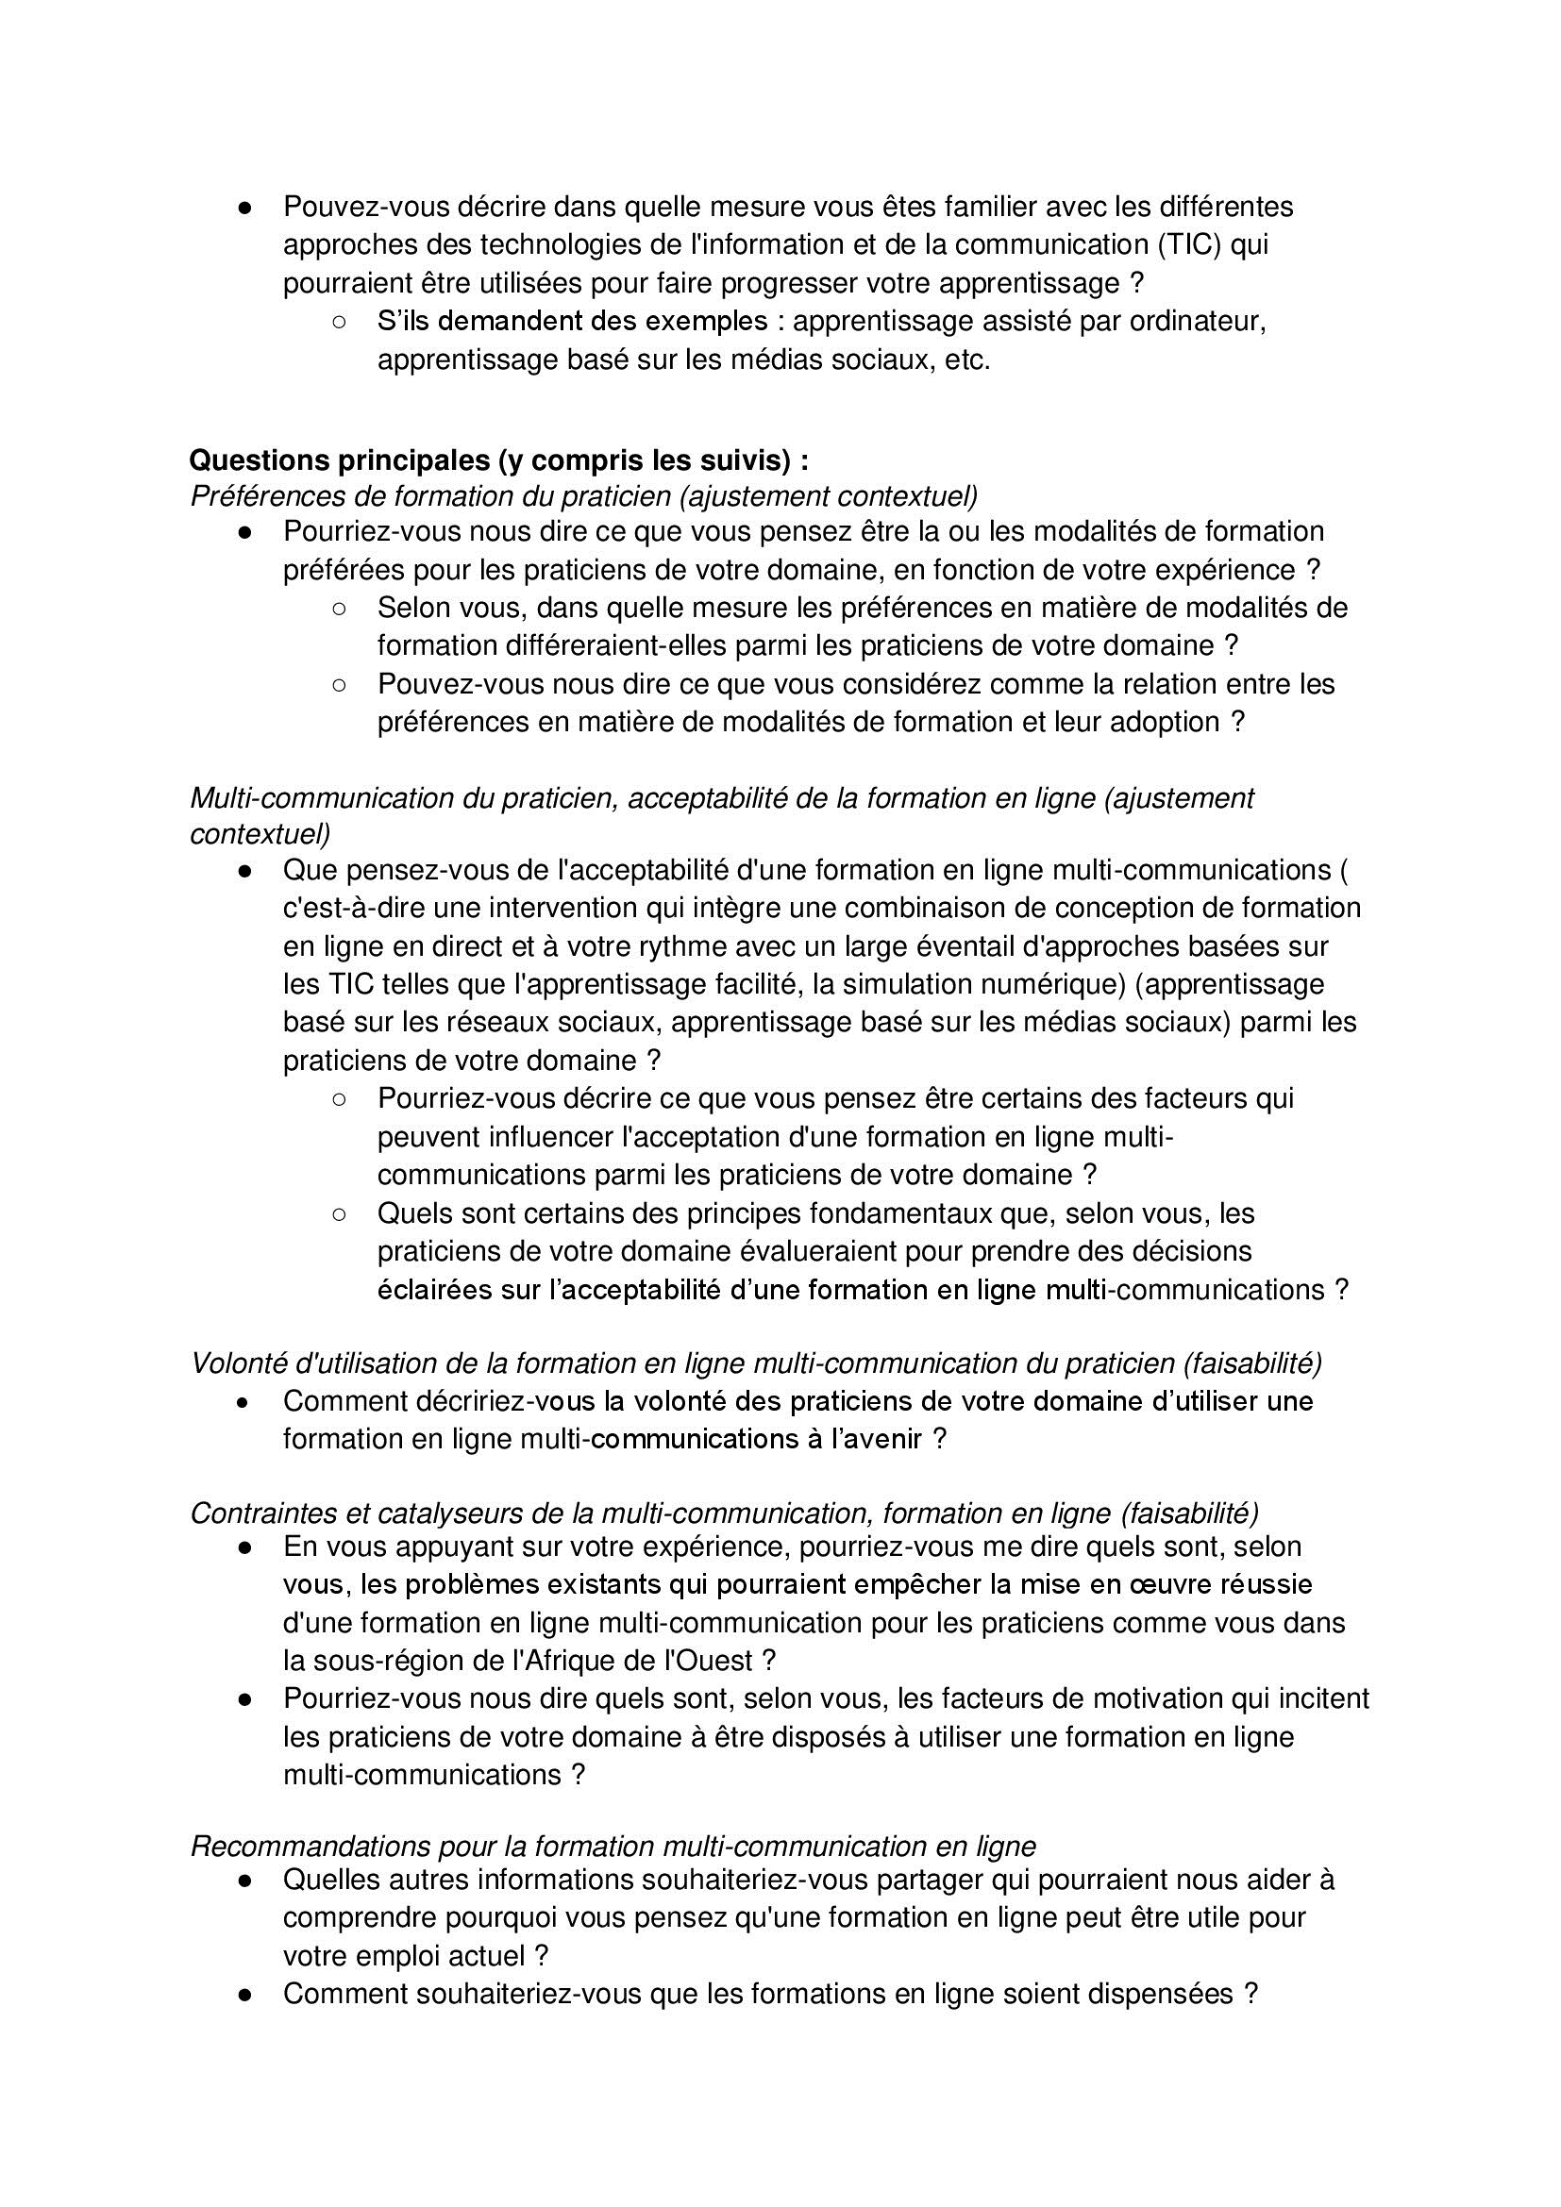

Appendix 6. Assumptions underlying analysis

For this study, our analytic approach involved the combination of the “Not sure” and “No” responses for “acceptability” and “willingness to use” study outcomes as “No” value based on some evidence-informed assumptions.

First, we considered the knowledge of the participants towards e-learning relative to its technological stage of development based on performance analysis of technology,¹ which could have informed their behavioral choices in terms of acceptability of and willingness to use e-learning, as conceptualized in appendix 2. Second, we considered the context in which their behavioral choices were made relative to the propensity of adoption of the study’s e-learning intervention based on the diffusion of innovation theory,² as shown in figure 1 below.

While a “Not sure” response to our behavioral questions on acceptability of and willingness to use e-learning could reflect multiple scenarios, including 1) lack of participant’s knowledge about the topic of interest needed to make an informed choice, 2) social desirable response, and 3) a true state of an undecided choice, we made our first assumption that public health workers were well knowledgeable about e-learning in part due to its advanced stage of development (i.e., stage 4: maturity or proven effectiveness) to make decisive informed choices. Hence, “Not sure” response was taken as a true state of an undecided choice. Applying both the performance analysis of technology and the diffusion of innovation theory, participants with “Not sure” responses were interpreted as potential “late majority adopters or skeptics” and/or “laggards or resisters”. In addition, given the understanding that the propensity for adoption of any innovation reduces along its technological stage of development after its maturity and that when skeptics adopt innovations, they do so out of “necessity” and not by “choice” as proposed in our conceptual framework. Therefore, we determined participants with “Not sure” responses to be similar to those with “No” responses.

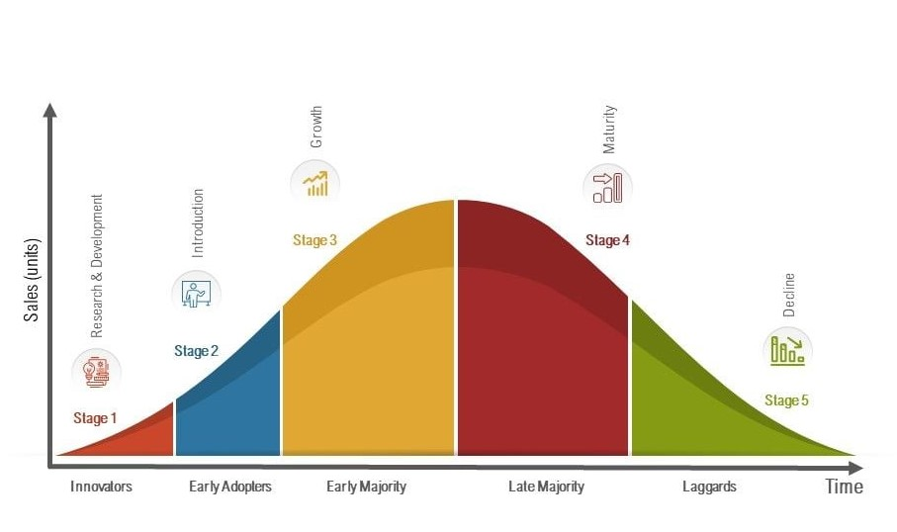

Fig 1. Stage of development of technology and its adoption curve based on performance analysis of technology and diffusion of innovation theory.^{1,2}

References
1. Nieto M, Lopéz F, Cruz F. Performance analysis of technology using the S curve model: the case of digital signal processing (DSP) technologies. Technovation. 1998;18(6-7):439-457.

2. Rogers EM. Diffusion of innovations. 5th ed. New York. Free Press; 2003.

Appendix 7. Baseline assessment of sample and sample weights computation

To improve representativeness of the aggregated results, two statistical weighting strategies were employed. First, an inverse probability weighting was employed to account for unequal probability of selection of participants due to lack of a sampling frame based on the non-probability sampling technique (i.e., virtual snowball sampling) used in this study.

Second, given evidence of unequal distributions of the sample population’s baseline characteristic (country) to the target population in figure 1 below, we performed post-stratification weighting at the country level using the cell weighting method in SAS version 9.4 (SAS Institute, Cary, North Carolina, USA).

The distribution for the country level was based on data from the WHO report on health workforce in the African region in 2018,¹ which is summarized in Appendix 8. Country variable was only included because of lack of distribution of the health workforce by other important sociodemographic characteristics (e.g., age, sex, sector) in the report.

Final weights (Wfinal) were computed as a product of inverse probability weight (Wipw) and post-stratification weight (Wpsw)

Inverse probability weight (Wipw)

$π_{scp}$ = $(π_{c|s}$) ($π_{p|cs}$)

When:

$π_{c|s}$: probability of selecting a country given a language group. Calculated as the number of countries sampled in respective language strata divided by the total number of countries in the language strata.

$π_{p|s}$ was assigned as 1 for each country since all the 16 countries of the West African subregion were represented in the online survey.

$π_{p|cs}$: probability of selecting a public health worker given a country and language group. Calculated as the number of public health workers sampled in a country divided by the total number of public health workers in the country.

Wipw = $\frac{1}{π_{scp}}$

Post-stratification weight (Wpsw)

Wpsw = $\frac{Subregional population \%}{Sample population \%}$

$Subregional population \%$: proportion of the subregional population of public health workers (i.e., target population) in each country. Calculated as the number of public health workers in each country divided the total number of public health workers in the subregional population multiplied by 100.

$Sample population \%$: proportion of the sample population of public health workers (i.e., study population) in each country. Calculated as the number of public health workers in each country divided the total number of public health workers in the sample population multiplied by 100.

Final weights (Wfinal)

Wfinal = Wipw x Wpsw

Appendix 7 Fig. 1. Baseline assessment of study population distribution by country to the West African public health workers population

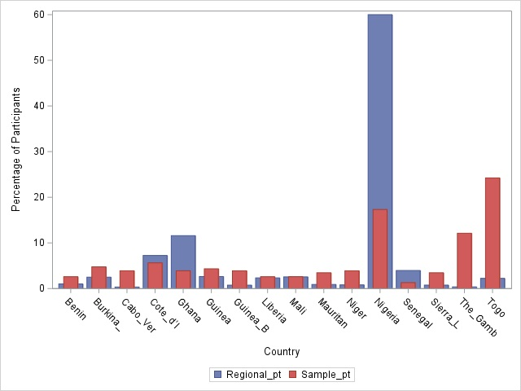

Reference
1. World Health Organization. The State of the Health Workforce in the WHO African Region, 2021. 2021. Available: https://iris.who.int/bitstream/handle/10665/348855/9789290234555-eng.pdf?sequence=1. Accessed: 10 March 2023.

Appendix 8. Distribution of public health workers, gross domestic product per capita, and global health security index in West Africa

 | Total Population¹  (2018)  n | Public Health Workers²  (2018)  n | Proportion of PH  % | PH:P Ratio  (2018) | GDP per capita³  (2018)  $ | GHS Index⁴  (2019)
Subregion
West Africa | 390,953,045 | 1,054,042 | 0.27 (270 per 100,000) | 1:371 | 2,594 | 32.3
Country  Benin | 11,940,683 | 10,630 | 1.01 | 1:1,124 | 2,220 | 28.8
Burkina Faso | 20,392,723 | 26,305 | 2.50 | 1:776 | 1,590 | 30.1
Cabo Verde | 571,202 | 3,537 | 0.34 | 1:162 | 6,831 | 29.3
Cote d’Ivoire | 25,493,988 | 76,376 | 7.25 | 1:334 | 3,714 | 35.5
Ghana | 30,870,641 | 122,183 | 11.59 | 1:253 | 4,267 | 35.5
Guinea | 12,554,864 | 27,857 | 2.64 | 1:451 | 1,606 | 32.7
Guinea-Bissau | 1,924,955 | 7,890 | 0.75 | 1:244 | 1,501 | 20.0
Liberia | 5,193,416 | 24,620 | 2.34 | 1:211 | 818 | 35.1
Mali | 21,904,983 | 26,976 | 2.56 | 1:812 | 1,667 | 29.0
Mauritania | 4,614,974 | 9,454 | 0.90 | 1:489 | 3,458 | 27.5
Niger | 22,577,058 | 8,554 | 0.81 | 1:2,640 | 965 | 32.2
Nigeria | 198,387,623 | 632,325 | 60.0 | 1:314 | 5,238 | 37.8
Senegal | 15,574,909 | 41,781 | 3.96 | 1:373 | 2,617 | 37.9
Sierra Leone | 7,861,281 | 8,054 | 0.76 | 1:976 | 1,684 | 38.2
The Gambia | 2,444,916 | 3,924 | 0.37 | 1:623 | 1,882 | 34.2
Togo | 8,644,829 | 23,576 | 2.24 | 1:367 | 1,451 | 32.5
n – frequency; % – percentage of public health workers in each country among all public health workers; $ – international dollar, PH:P – public health worker-population, GDP – gross domestic product, and GHS – global health security index. Note that PH:P, GDP per capita, and GHS index for West Africa were calculated as average of their values for respective countries.

References
1. The World Bank. Population, total- Sub-saharan Africa. 2018. Available: https://data.worldbank.org/indicator/SP.POP.TOTL?locations=ZG. Accessed: 12 March 2023.

2. World Health Organization. The State of the Health Workforce in the WHO African Region, 2021. 2021. Available: https://iris.who.int/bitstream/handle/10665/348855/9789290234555-eng.pdf?sequence=1. Accessed: 10 March 2023.

3. Our World in Data. GDP per capita, 2018. Available: https://ourworldindata.org/grapher/gdp-per-capita-maddison. Accessed; 12 March 2023.

4. Nuclear Threat Initiative. 2019 Global Health Security Index. 2019. Available: https://ghsindex.org/wp-content/uploads/2019/10/2019-Global-Health-Security-Index.pdf. Accessed: 12 March 2023.
Appendix 9. Normality tests

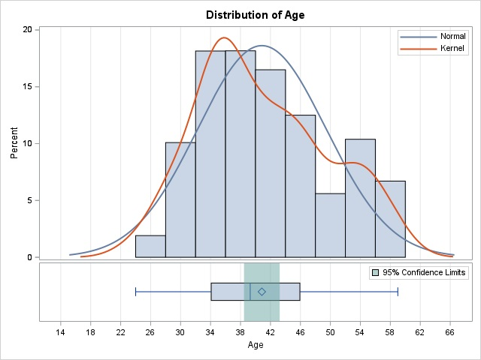

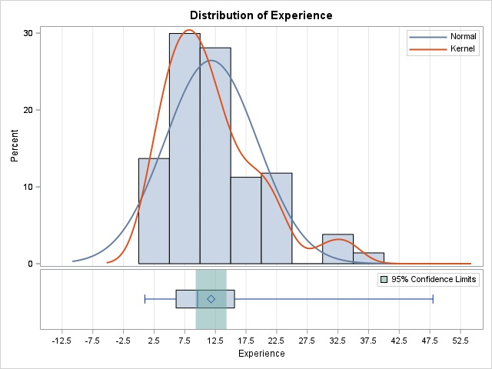

Appendix 10. Braun & Clarke 15-point Thematic Analysis checklist

Process | No | Criteria | Response
Transcription | 1. | The data have been transcribed to an appropriate level of detail, and the transcripts have been checked against the tapes for ‘accuracy’. | All seven in-depth interviews transcribed to an appropriate level of detail and checked against tapes.
Coding | 2. | Each data item has been given equal attention in the coding process. | We reviewed all quotations to generate coding.
 | 3. | Themes have not been generated from a few vivid examples (an anecdotal approach) but, instead, the coding process has been thorough, inclusive and comprehensive. | Themes, and the findings described herein were developed from a complete coding process of the entire dataset. The coding process was thorough, inclusive, and robust, as all quotations were used to generate codes, and develop themes. Each theme was developed based on numerous codes gathered across a range of participants quotations.
 | 4. | All relevant extracts for all each theme have been collated. | Yes.
 | 5. | Themes have been checked against each other and back to the original data set. | Yes.
 | 6. | Themes are internally coherent, consistent, and distinctive. | Yes.
Analysis | 7. | Data have been analysed rather than just paraphrased or described. | Yes.
Analysis | 8. | Analysis and data match each other – the extracts illustrate the analytic claims. | Yes.
Analysis | 9. | Analysis tells a convincing and well-organised story about the data and topic. | Yes.
Analysis | 10. | A good balance between analytic narrative and illustrative extracts is provided. | Yes.
Overall | 11. | Enough time has been allocated to complete all phases of the analysis adequately, without rushing a phase or giving it a once-over-lightly. | Yes.
Written report | 12. | The assumptions about thematic analysis are clearly explicated. | Yes.
Written report | 13. | There is a good fit between what you claim you do, and what you show you have done – ie, described method and reported analysis are consistent. | Yes.
Written report | 14. | The language and concepts used in the report are consistent with the epistemological position of the analysis. | Yes.
Written report | 15. | The researcher is positioned as active in the research process; themes do not just ‘emerge’. | Yes.

Reference
1. Braun V, Clarke V. Using thematic analysis in psychology. Qual Res Psychol. 2006;3:77-101.

Appendix 11. Frequency and geospatial distributions of multi-communication online training (MOT) preference, acceptability, willingness to use, and workplace ICT availability

Appendix 11 Table 1. Frequency distribution of MOT preference

Characteristic MOT Preference
N = 231 Nw = 2,873,004
 | n | nw (%w) |  | p-value
West Africa  Overall (95% CI= 23.96-35.27) | 63 | 850759 (29.61)
Downstream factor  Country§  Benin | 3 | 2065 (50.00) |  | 0.0006
Burkina Faso | 2 | 2512 (18.18)
Cabo Verde | 5 | 171 (55.56)
Cote d’Ivoire | 1 | 7566 (7.69)
Ghana | 3 | 121034 (33.33)
Guinea | 6 | 10191 (60.00)
Guinea-Bissau | 1 | 168 (11.11)
Liberia | 2 | 7386 (33.33)
Mali | 2 | 8854 (33.33)
Mauritania | 7 | 2152 (87.50)
Niger | 2 | 395 (22.22)
Nigeria | 11 | 602388 (27.50)
Senegal | 2 | 84847 (66.67)
Sierra Leone | 3 | 663 (37.50)
The Gambia | 4 | 17 (14.29)
Togo | 9 | 350 (16.07)
Areaǂ  Rural | 20 | 215633 (35.29) |  | 0.0386
Urban | 43 | 635126 (28.08)
Ageǂ (yrs) Median: 39, IQR= 34-46  ≤ 29 | 13 | 221318 (77.12) |  | 0.0028
30-39 | 21 | 258730 (23.50)
40-49 | 21 | 154388 (16.38)
50-59 | 8 | 216322 (39.90)
Sexǂ |  |  |  | 0.0051
Female | 27 | 399086 (38.06)
Male | 36 | 451673 (24.76)
MOT – multi-communication online training. n – number of participants with a characteristic that indicated yes to MOT preference. nw – weighted number of those participants. %w – weighted proportion of those participants among all participants with the same characteristic. CI – confidence interval. Bold p-value indicate statistically significant (p<0.05). ǂFrom Rao-Scott Chi-square test. §From Fisher’s exact test. Yrs – years. IQR – interquartile range.

Characteristic MOT Preference
 | n | nw (%w) | p-value
Discipline§  Environmental health scientist/technician | 13 | 145757 (40.47) | 0.2287
Laboratory scientist/technician | 6 | 44724 (43.63)
Nurse | 6 | 51275 (70.24)
Physician | 4 | 548 (0.10)
Public health specialist | 26 | 387691 (37.06)
Veterinarian/assistant veterinarian | 4 | 56255 (13.69)
Others | 6 | 164509 (48.69)
Sector§  Animal | 5 | 111017 (20.49) | 0.0046
Environment | 16 | 148898 (35.60)
Human | 42 | 590843 (30.88)
Work experience§ (yrs) Median: 10, IQR= 6-16  ≤ 5 | 14 | 11.5144 (53.56) | 0.1573
6-10 | 14 | 5.0916 (15.56)
11-15 | 14 | 6.9302 (33.75)
16-20 | 17 | 4.1577 (31.97)
21-25 | 4 | 1.9183 (27.35)
26-30 | 0 | 0
> 30 | 0 | 0
Setting§  Government public health institution | 20 | 154254 (19.46) | 0.0005
Government environment health institution | 4 | 41288 (46.13)
Government animal health institution | 1 | 39 (0.04)
Private public health institution | 11 | 153068 (47.94)
Private environment health institution | 1 | 39 (0.07)
Private animal health institution | 0 | 0
Human hospital/clinic (public or private) | 9 | 161017 (36.22)
Animal hospital/clinic (public or private) | 1 | 54763 (56.80)
Academia (public or private) | 2 | 1703 (0.76)
Community-based organization | 2 | 3727 (37.83)
Non-governmental organization | 9 | 279077 (44.04)
Faith-based organization | 1 | 307 (0.56)
Others | 2 | 1477 (2.32)
Table 1 (cont’d 1). n – number of participants with a characteristic that indicated yes to MOT preference. nw – weighted number of those participants. %w – weighted proportion of those participants among all participants with the same characteristic. Bold p-value indicate statistically significant (p<0.05). ǂFrom Rao-Scott Chi-square test. §From Fisher’s exact test. yrs – years. IQR – interquartile range.

Midstream factors  Self-efficacy§  Yes | 62 | 795996 (28.28) | 0.2968
No | 1 | 54763 (94.19)
Effort expectancy§  Yes | 61 | 847805 (30.03) | 0.1090
No | 2 | 2954 (5.93)
Performance expectancy§  Yes | 59 | 849422 (31.90) | 0.0037
No | 4 | 1337 (0.64)
Attitude§  Yes | 63 | 850759 (32.08) | <.0001
No | 0 | 0
Social influenceǂ  Yes | 52 | 744924 (31.62) | 0.4934
No | 11 | 105835 (20.46)
Previous e-learningǂ  Yes | 56 | 733400 (27.23) | <.0001
No | 7 | 117359 (65.27)
Upstream factor  Workplace internet fundingǂ  Yes | 26 | 521882 (41.08) | 0.0004
No | 37 | 328877 (20.52)
Table 1 (cont’d 2). n – number of participants with a characteristic that indicated yes to MOT preference. nw – weighted number of those participants. %w – weighted proportion of those participants among all participants with the same characteristic. Bold p-value indicate statistically significant (p<0.05). ǂFrom Rao-Scott Chi-square test. §From Fisher’s exact test. yrs – years. IQR – interquartile range.

Appendix 11 Fig. 1. Geospatial distribution of MOT preference
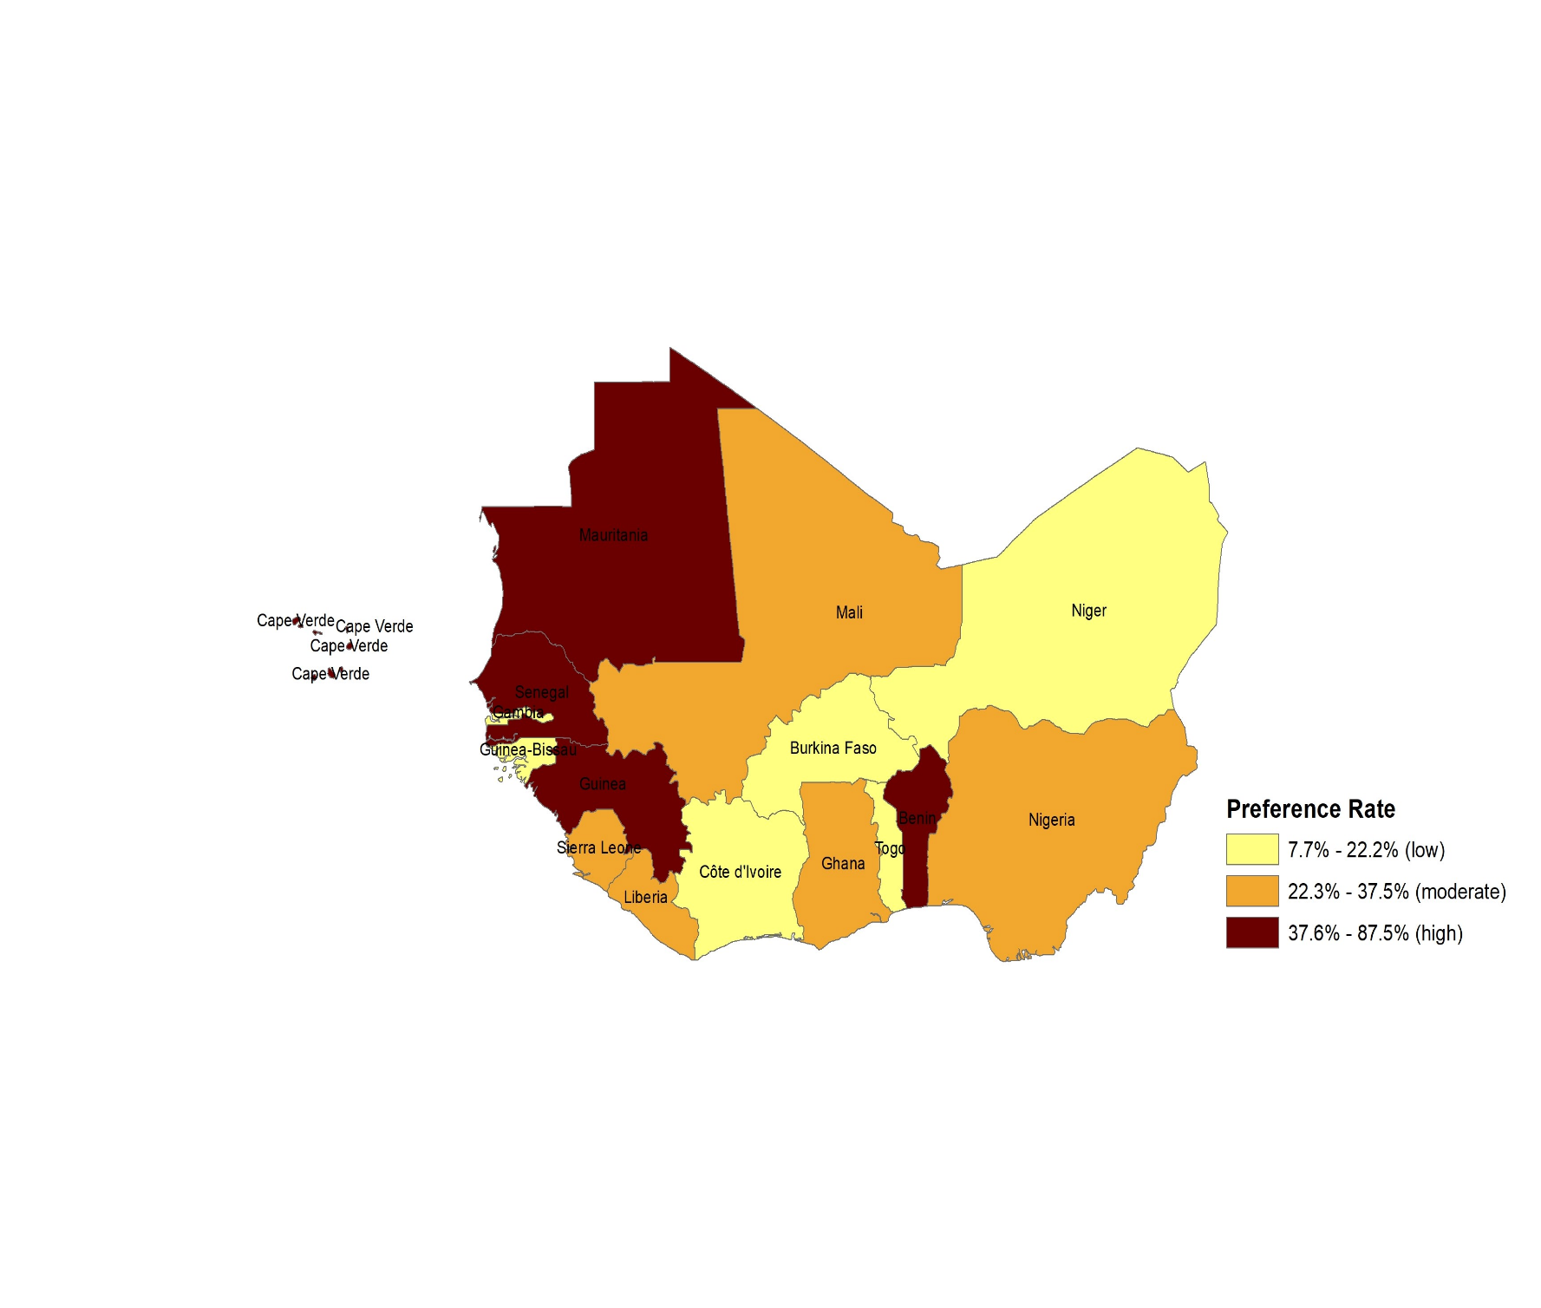

Appendix 11 Table 2. Frequency distribution of MOT acceptability

Characteristic MOT Acceptability
N = 231 Nw = 2,873,004
 | n | nw (%w) |  | p-value
West Africa  Overall (95% CI= 93.79-98.18) | 212 | 2757719 (95.99)
Downstream factor  Country§  Benin | 6 | 4129 (100.00) |  | 0.5257
Burkina Faso | 10 | 12560 (90.91)
Cabo Verde | 7 | 240 (77.78)
Cote d’Ivoire | 13 | 98352 (100.00)
Ghana | 9 | 363102 (100.00)
Guinea | 8 | 13588 (80.00)
Guinea-Bissau | 7 | 1180 (77.78)
Liberia | 6 | 22158 (100.00)
Mali | 6 | 26561 (100.00)
Mauritania | 7 | 2152 (87.50)
Niger | 9 | 1777 (100.00)
Nigeria | 38 | 2080976 (95.00)
Senegal | 3 | 127271 (100.00)
Sierra Leone | 7 | 1548 (87.50)
The Gambia | 24 | 102 (85.71)
Togo | 52 | 2023 (92.86)
Areaǂ  Rural | 58 | 498047 (81.50) |  | <.0001
Urban | 154 | 2259673 (99.90)
Age§ (yrs) Median: 39, IQR:34-46  ≤ 29 | 18 | 175395 (61.11) |  | 0.0432
30-39 | 81 | 1097807 (99.70)
40-49 | 78 | 942378 (99.96)
50-59 | 35 | 542140 (99.99)
Sexǂ |  |  |  | 0.1729
Female | 62 | 990473 (94.46)
Male | 150 | 1767246 (96.87)
MOT – multi-communication online training. n – number of participants with a characteristic that indicated yes to MOT acceptability. nw – weighted number of those participants. %w – weighted proportion of those participants among all participants with the same characteristic. CI – confidence interval. Bold p-value indicate statistically significant (p<0.05). ǂFrom Rao-Scott Chi-square test. §From Fisher’s exact test. yrs – years. IQR – interquartile range.

Characteristic MOT Acceptability
 | n | nw (%w) | p-value
Discipline§  Environmental health scientist/technician | 28 | 305221 (84.74) | 0.4792
Laboratory scientist/technician | 15 | 102309 (99.80)
Nurse | 19 | 71222(97.57)
Physician | 21 | 542387 (99.99)
Public health specialist | 94 | 1046020 (99.99)
Veterinarian/assistant veterinarian | 25 | 407446 (99.15)
Others | 10 | 283115 (83.79)
Sector§  Animal | 33 | 538505 (99.41) | 0.1718
Environment | 28 | 362934 (86.78)
Human | 151 | 1856280 (97.03)
Work experience§ (yrs) Median: 10, IQR= 6-16  ≤ 5 | 33 | 506255 (81.96) | 0.0685
6-10 | 61 | 936505 (99.60)
11-15 | 50 | 589954 (99.99)
16-20 | 42 | 373476 (99.97)
21-25 | 18 | 201534 (100.00)
26-30 | 4 | 54810 (99.98)
> 30 | 4 | 95185 (100.00)
Setting§  Government public health institution | 103 | 790880 (99.78) | 0.4400
Government environment health institution | 8 | 988 (99.77)
Government animal health institution | 12 | 90440 (99.71)
Private public health institution | 16 | 319300 (100.00)
Private environment health institution | 3 | 54840 (100.00)
Private animal health institution | 0 | 0
Human hospital/clinic (public or private) | 21 | 388063 (87.30)
Animal hospital/clinic (public or private) | 5 | 96406 (100.00)
Academia (public or private) | 13 | 222784 (100.00)
Community-based organization | 3 | 8154 (82.76)
Non-governmental organization | 21 | 578695 (91.33)
Faith-based organization | 3 | 55109 (100.00)
Others | 4 | 63805 (100.00)
Table 2 (cont’d 1). n – number of participants with a characteristic that indicated yes to MOT acceptability. nw – weighted number of those participants. %w – weighted proportion of those participants among all participants with the same characteristic. Bold p-value indicate statistically significant (p<0.05). ǂFrom Rao-Scott Chi-square test. §From Fisher’s exact test. yrs – years. IQR – interquartile range.

Midstream factors  Self-efficacy§  Yes | 204 | 2702572 (96.01) | 0.0512
No | 8 | 55148 (94.85)
Effort expectancy§  Yes | 197 | 2712623 (96.08) | 0.0572
No | 15 | 45096 (90.58)
Performance expectancy§  Yes | 183 | 2549462 (95.76) | 0.1930
No | 29 | 208257 (98.88)
Attitudeǂ  Yes | 184 | 2539051 (97.73) | 0.1193
No | 28 | 218668 (99.09)
Social influence§  Yes | 156 | 2300659 (97.67) | <.0001
No | 56 | 457061 (88.34)
Previous e-learning§  Yes | 186 | 2636430 (97.89) | 0.1489
No | 26 | 121289 (67.46)
Upstream factor  Workplace internet fundingǂ  Yes | 66 | 1215502 (95.68) | 0.5160
No | 146 | 1542218 (96.23)
Table 2 (cont’d 2). n – number of participants with a characteristic that indicated yes to MOT acceptability. nw – weighted number of those participants. %w – weighted proportion of those participants among all participants with the same characteristic. Bold p-value indicate statistically significant (p<0.05). ǂFrom Rao-Scott Chi-square test. §From Fisher’s exact test. yrs – years. IQR – interquartile range.

Appendix 11 Fig. 2. Geospatial distribution of MOT acceptability
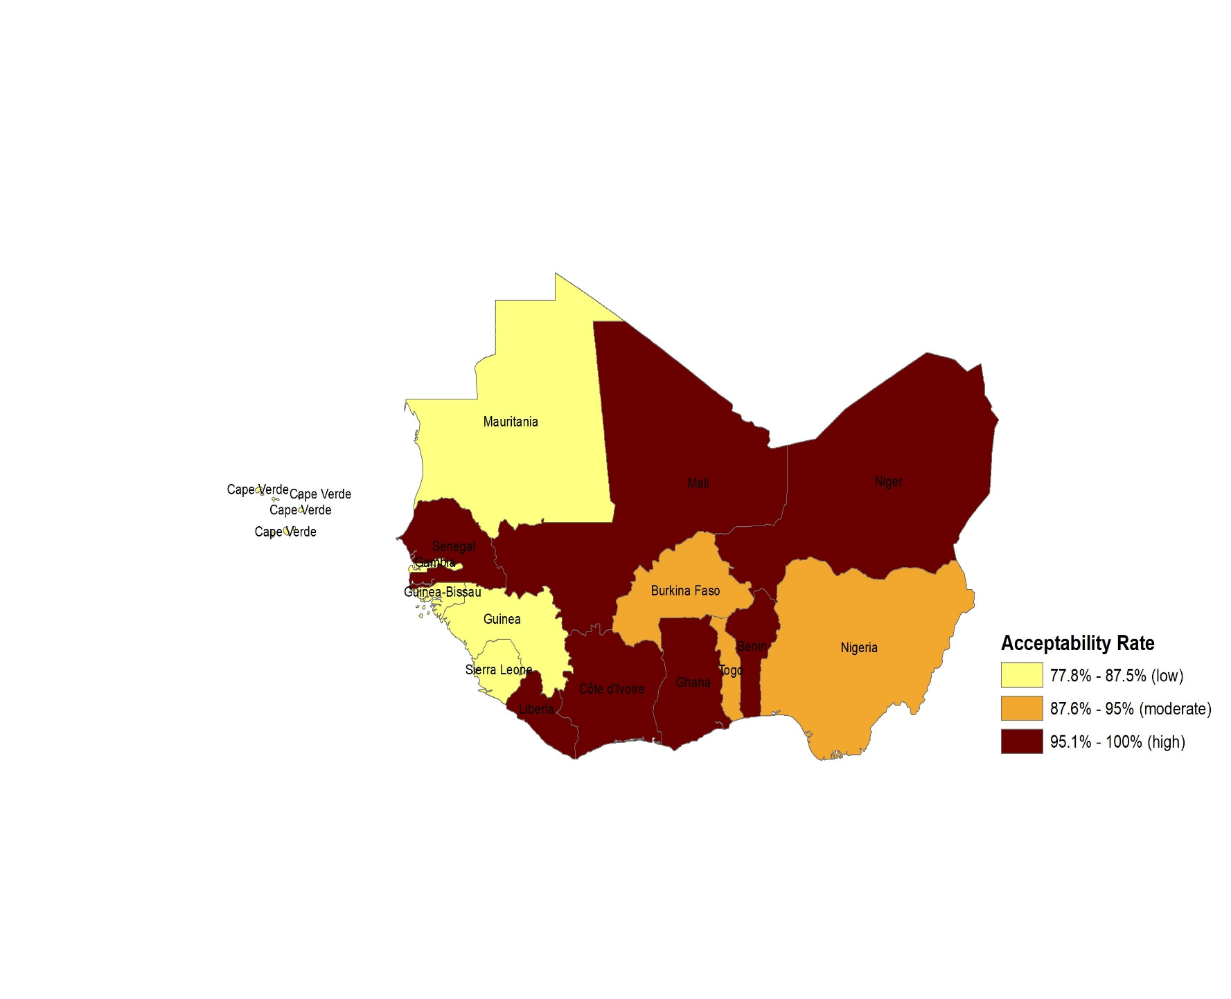

Appendix 11 Table 3. Frequency distribution of MOT willingness to use

Characteristic MOT Willingness to Use
N = 231 Nw = 2,873,004
 | n | nw (%w) |  | p-value
West Africa  Overall (95% CI= 93.78-97.35) | 214 | 2745503 (95.56)
Downstream factor  Country§  Benin | 6 | 4129 (100.00) |  | <.0001
Burkina Faso | 9 | 11304 (81.82)
Cabo Verde | 9 | 308 (100.00)
Cote d’Ivoire | 12 | 90787 (92.31)
Ghana | 9 | 363102 (100.00)
Guinea | 8 | 13588 (80.00)
Guinea-Bissau | 7 | 1180 (77.78)
Liberia | 5 | 18465 (83.33)
Mali | 6 | 26561 (100.00)
Mauritania | 7 | 2152 (87.50)
Niger | 9 | 1777 (100.00)
Nigeria | 38 | 2080976 (95.00)
Senegal | 3 | 127271 (100.00)
Sierra Leone | 8 | 1769 (100.00)
The Gambia | 26 | 111 (92.86)
Togo | 52 | 2023 (92.86)
Areaǂ  Rural | 59 | 545243 (89.23) |  | <.0001
Urban | 155 | 2200260 (97.27)
Age§ (yrs) Median: 39, IQR= 34-46  ≤ 29 | 19 | 230157 (80.20) |  | 0.0782
30-39 | 82 | 1097807 (99.70)
40-49 | 79 | 931384 (98.80)
50-59 | 34 | 486156 (89.67)
Sex§ |  |  |  | 1.0000
Female | 63 | 1041577 (99.33)
Male | 151 | 1703926 (93.40)
MOT – multi-communication online training. n – number of participants with a characteristic that indicated yes to MOT willingness to use. nw – weighted number of those participants. %w – weighted proportion of those participants among all participants with the same characteristic. CI – confidence interval. Bold p-value indicate statistically significant (p<0.05). ǂFrom Rao-Scott Chi-square test. §From Fisher’s exact test. yrs – years. IQR – interquartile range.

Characteristic MOT Willingness to Use
 | n | nw (%w) | p-value
Discipline§  Environmental health scientist/technician | 28 | 297694 (82.65) | 0.0980
Laboratory scientist/technician | 16 | 102348 (99.84)
Nurse | 18 | 71183 (97.51)
Physician | 22 | 542421 (100.00)
Public health specialist | 95 | 1041114 (99.53)
Veterinarian/assistant veterinarian | 25 | 352904 (85.88)
Others | 10 | 337839 (99.99)
Sector§  Animal | 34 | 484003 (89.35) | 0.3820
Environment | 29 | 355412 (84.98)
Human | 151 | 1906088 (99.64)
Work experience§ (yrs) Median: 10, IQR= 6-16  ≤ 5 | 34 | 561017 (90.83) | 0.0161
6-10 | 62 | 936687 (99.62)
11-15 | 49 | 578700 (98.09)
16-20 | 44 | 372332 (99.66)
21-25 | 18 | 201534 (100.00)
26-30 | 3 | 48 (0.09)
> 30 | 4 | 95185 (100.00)
Setting§  Government public health institution | 102 | 731168 (92.25) | 0.3609
Government environment health institution | 8 | 81716 (91.35)
Government animal health institution | 14 | 90700 (100.00)
Private public health institution | 16 | 319300 (100.00)
Private environment health institution | 3 | 54840 (100.00)
Private animal health institution | 0 | 0
Human hospital/clinic (public or private) | 22 | 442826 (99.62)
Animal hospital/clinic (public or private) | 5 | 96406 (100.00)
Academia (public or private) | 13 | 222784 (100.00)
Community-based organization | 3 | 8154 (82.76)
Non-governmental organization | 21 | 578695 (91.33)
Faith-based organization | 3 | 55109 (100.00)
Others | 4 | 63805 (100.00)
Table 3 (cont’d 1). n – number of participants with a characteristic that indicated yes to MOT willingness to use. nw – weighted number of those participants. %w – weighted proportion of those participants among all participants with the same characteristic. Bold p-value indicate statistically significant (p<0.05). ǂFrom Rao-Scott Chi-square test. §From Fisher’s exact test. yrs – years. IQR – interquartile range.

Midstream factors  Self-efficacy§  Yes | 206 | 2690355 (95.58) | 0.0379
No | 8 | 55148 (94.85)
Effort expectancy§  Yes | 199 | 2700407 (93.99) | 0.0392
No | 15 | 45096 (90.58)
Performance expectancyǂ  Yes | 181 | 2538169 (88.35) | 0.3065
No | 33 | 207334 (98.44)
Attitudeǂ  Yes | 184 | 2530156 (88.07) | 0.5899
No | 33 | 215347 (97.58)
Social influenceǂ  Yes | 153 | 2288139 (79.64) | 0.1040
No | 61 | 457364 (88.40)
Previous e-learning§  Yes | 188 | 2569490 (89.44) | 0.0596
No | 26 | 176013 (97.90)
Upstream factor  Workplace internet fundingǂ  Yes | 69 | 1215579 (42.31) | 0.1020
No | 145 | 1529924 (95.46)
Table 3 (cont’d 2). n – number of participants with a characteristic that indicated yes to MOT willingness to use. nw – weighted number of those participants. %w – weighted proportion of those participants among all participants with the same characteristic. Bold p-value indicate statistically significant (p<0.05). ǂFrom Rao-Scott Chi-square test. §From Fisher’s exact test. yrs – years. IQR – interquartile range.

Appendix 11 Fig. 3. Geospatial distribution of MOT willingness to use
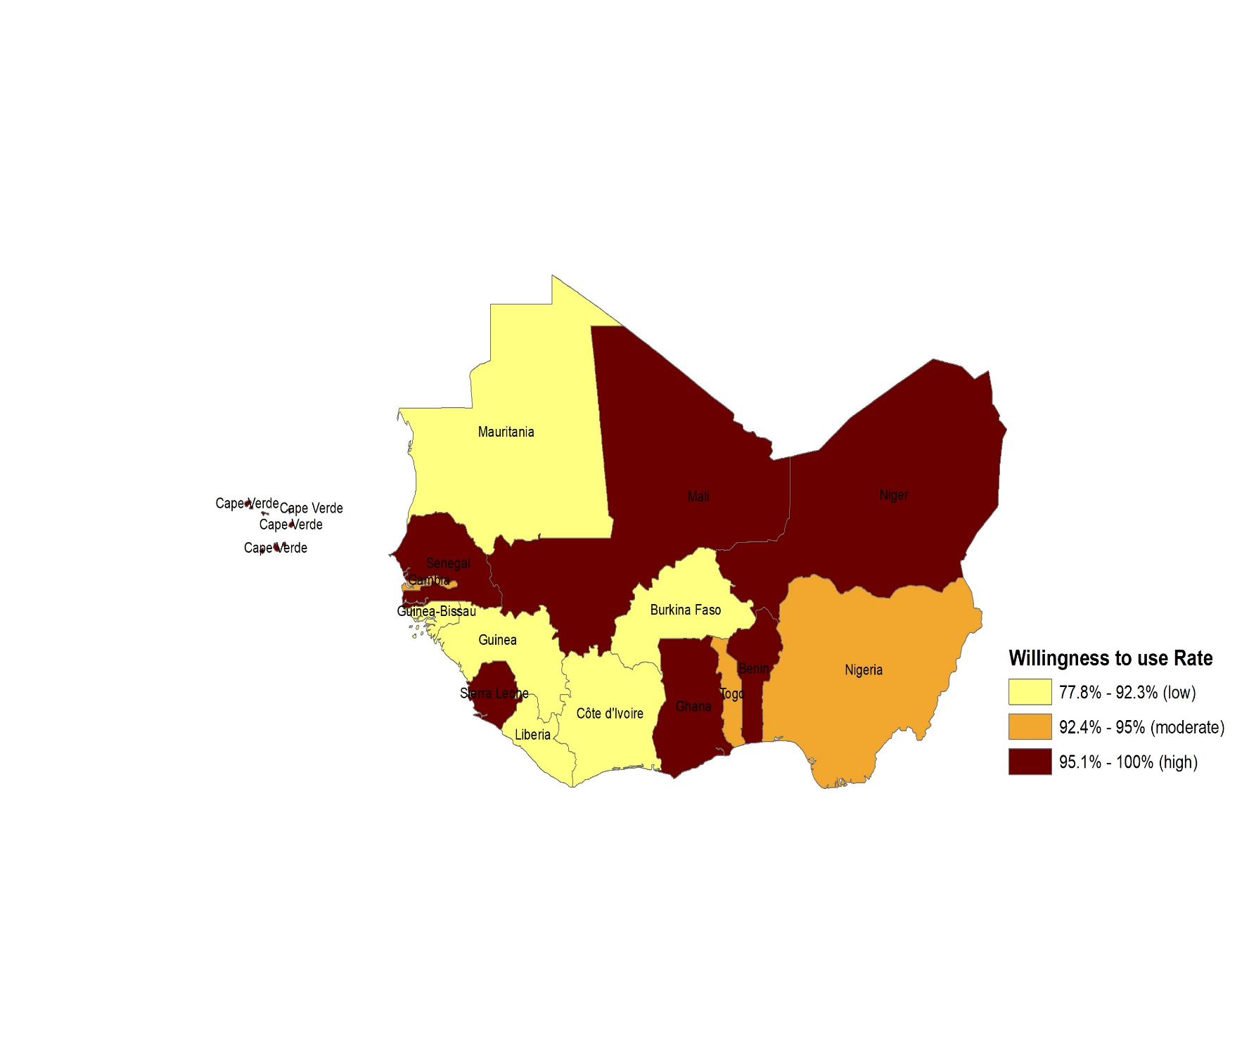

Appendix 11 Table 4. Frequency distribution of MOT workplace ICT availability

Characteristic Workplace ICT Availability
N = 231 Nw = 2,873,004
 | n | nw (%w) |  | p-value
West Africa  Overall (95% CI= 77.50-86.68) | 156 | 2358486 (82.09)
Downstream factor  Country§  Benin | 2 | 1376 (33.33) |  | 0.0020
Burkina Faso | 8 | 10048 (72.73)
Cabo Verde | 3 | 103 (33.33)
Cote d’Ivoire | 12 | 90787 (92.31)
Ghana | 8 | 322758 (88.89)
Guinea | 7 | 11889 (70.00)
Guinea-Bissau | 7 | 1180 (77.78)
Liberia | 4 | 14772 (66.67)
Mali | 5 | 22134 (83.33)
Mauritania | 2 | 615 (25.00)
Niger | 6 | 1184 (66.67)
Nigeria | 32 | 1752401 (80.00)
Senegal | 3 | 127271 (100.00)
Sierra Leone | 3 | 663 (37.50)
The Gambia | 23 | 99 (82.14)
Togo | 31 | 1206 (55.36)
Areaǂ  Rural | 31 | 323595 (52.95) |  | <.0001
Urban | 125 | 2034891 (89.96)
Ageǂ (yrs) Median: 39, IQR= 34-46  ≤ 29 | 15 | 175586 (61.18) |  | 0.0024
30-39 | 47 | 823817 (74.82)
40-49 | 62 | 872221 (92.52)
50-59 | 32 | 486862 (89.80)
Sexǂ |  |  |  | <.0001
Female | 42 | 710848 (67.79)
Male | 114 | 1647638 (90.31)
MOT – multi-communication online training. n – number of participants with a characteristic that indicated yes to workplace ICT availability. nw – weighted number of those participants. %w – weighted proportion of those participants among all participants with the same characteristic. CI – confidence interval. Bold p-value indicate statistically significant (p<0.05). ǂFrom Rao-Scott Chi-square test. §From Fisher’s exact test. yrs – years. IQR – interquartile range.

Characteristic Workplace ICT Availability
 | n | nw (%w) | p-value
Discipline§  Environmental health scientist/technician | 20 | 358414 (99.51) | 0.0003
Laboratory scientist/technician | 9 | 100647 (98.18)
Nurse | 9 | 62176 (85.18)
Physician | 14 | 377670 (69.63)
Public health specialist | 81 | 921283 (88.07)
Veterinarian/assistant veterinarian | 14 | 309942 (75.43)
Others | 9 | 228353 (67.58)
Sector^{ǂ}  Animal | 21 | 384992 (71.07) | <.0001
Environment | 23 | 416279 (99.54)
Human | 112 | 1557215 (81.40)
Work experience§ (yrs) Median: 10, IQR= 6-16  ≤ 5 | 23 | 341509 (55.29) | 0.1882
6-10 | 43 | 829778 (88.25)
11-15 | 32 | 518570 (87.90)
16-20 | 36 | 372413 (99.69)
21-25 | 13 | 200976 (99.7)
26-30 | 6 | 54819 (100.00)
> 30 | 3 | 40423 (42.47)
Setting§  Government public health institution | 80 | 670178 (84.55) | 0.0071
Government environment health institution | 6 | 88502 (98.94)
Government animal health institution | 7 | 49452 (54.52)
Private public health institution | 11 | 315991 (98.96)
Private environment health institution | 3 | 54840 (100.00)
Private animal health institution | 0 | 0
Human hospital/clinic (public or private) | 10 | 273924 (61.62)
Animal hospital/clinic (public or private) | 4 | 96367 (99.96)
Academia (public or private) | 11 | 222581 (99.91)
Community-based organization | 1 | 3693 (37.48)
Non-governmental organization | 19 | 465646 (73.49)
Faith-based organization | 1 | 54763 (99.37)
Others | 3 | 62549 (98.03)
Table 4 (cont’d 1). MOT – multi-communication online training. ICT – information and communication technology. n – number of participants with a characteristic that indicated yes to workplace ICT availability. nw – weighted number of those participants. %w – weighted proportion of those participants among all participants with the same characteristic. Bold p-value indicate statistically significant (p<0.05). ǂFrom Rao-Scott Chi-square test. §From Fisher’s exact test. yrs – years. IQR – interquartile range.

Midstream factors  Self-efficacy§  Yes | 151 | 2358178 (83.78) | 0.1827
No | 5 | 307 (0.53)
Effort expectancyǂ  Yes | 146 | 2314801 (81.99) | 0.6779
No | 10 | 43684 (87.74)
Performance expectancyǂ  Yes | 133 | 2206484 (82.88) | 0.0250
No | 23 | 152002 (72.17)
Attitudeǂ  Yes | 130 | 2140174 (80.69) | <.0001
No | 26 | 218312 (98.93)
Social influenceǂ  Yes | 110 | 2022421 (85.85) | 0.3115
No | 46 | 336064 (64.96)
Previous e-learningǂ  Yes | 138 | 2292492 (85.12) | <.0001
No | 18 | 65994 (36.71)
Upstream factor  Workplace internet fundingǂ  Yes | 62 | 1210382 (95.28) | 0.0536
No | 94 | 1148104 (71.64)
Table 4 (cont’d 2). n – number of participants with a characteristic that indicated yes to workplace ICT availability. nw – weighted number of those participants. %w – weighted proportion of those participants among all participants with the same characteristic. Bold p-value indicate statistically significant (p<0.05). ǂFrom Rao-Scott Chi-square test. §From Fisher’s exact test. yrs – years. IQR – interquartile range.

Appendix 11 Fig. 4. Geospatial distribution of MOT workplace ICT availability
